Images

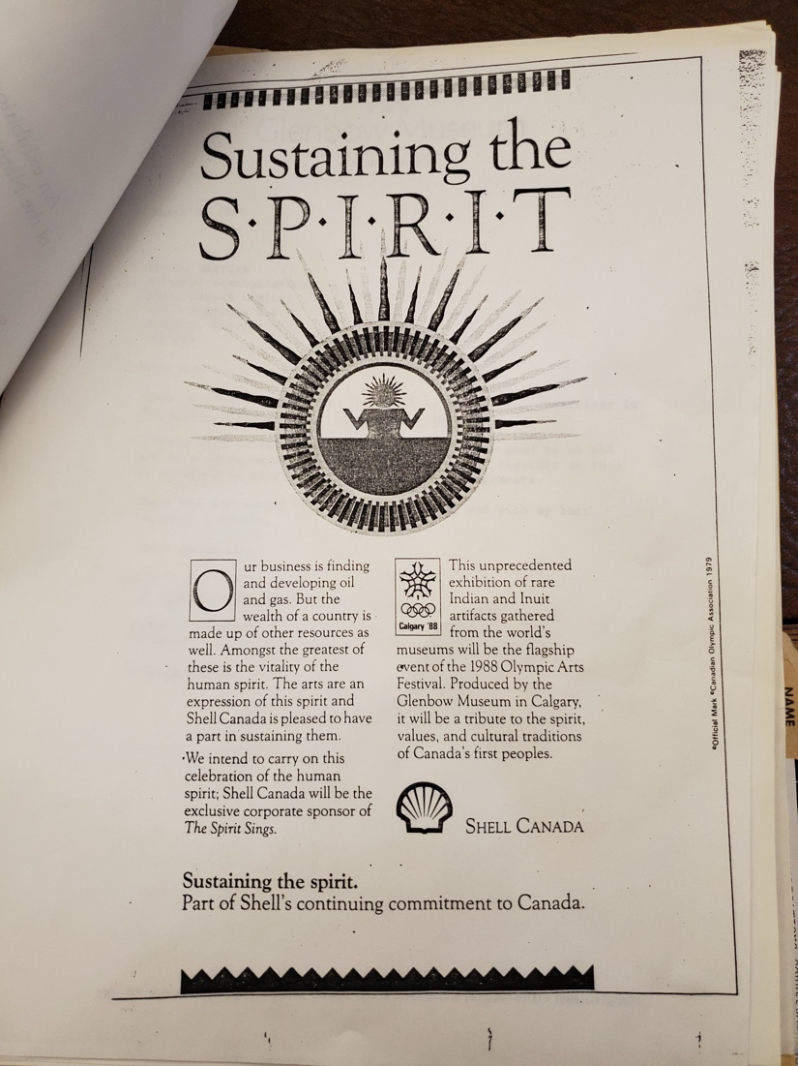
Image 1 (Glenbow Museum Archives)

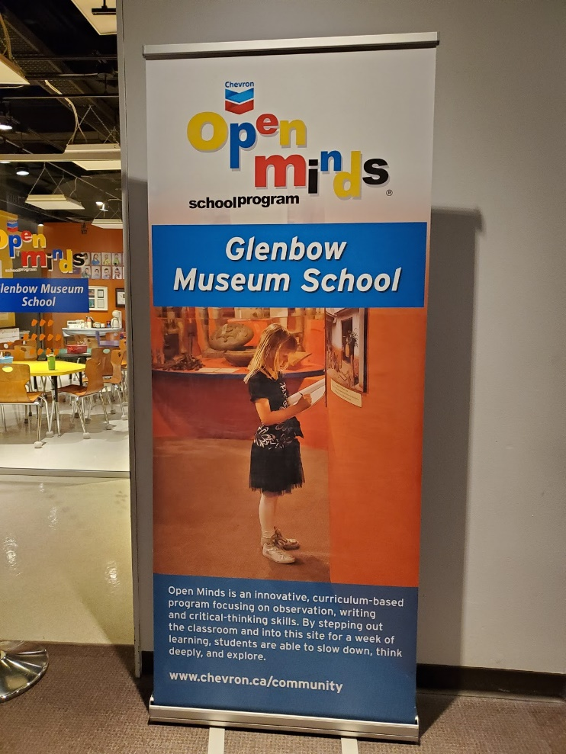
Image 2. Photo of a banner advertising the Glenbow Museum School, sponsored by Chevron. Glenbow Museum. 2019.

