**Blockchain and Digital Materiality: How digital materials can signify personal connections**

**Images**

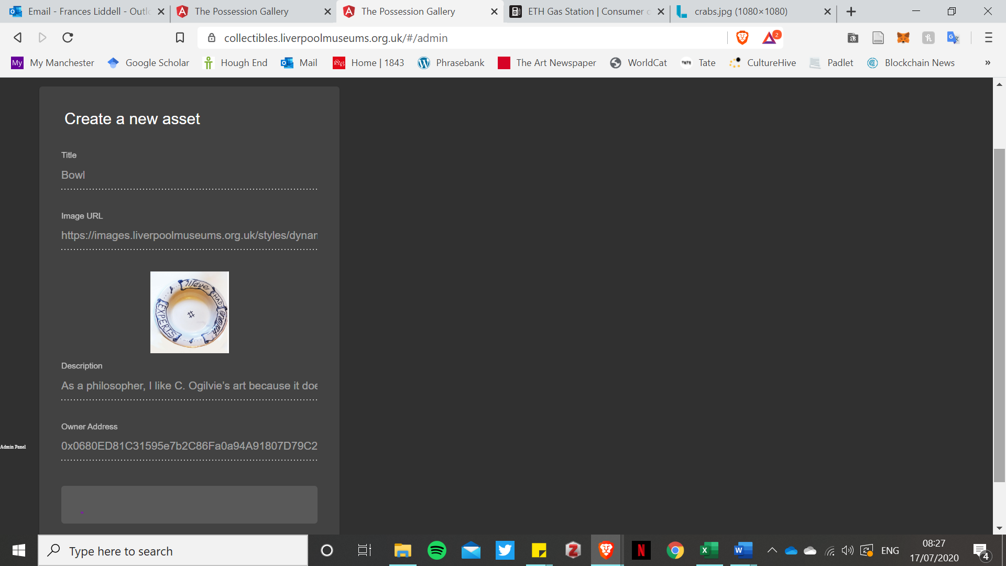

Figure 1: Box on admin page, Possession Gallery, Liverpool Museums Website

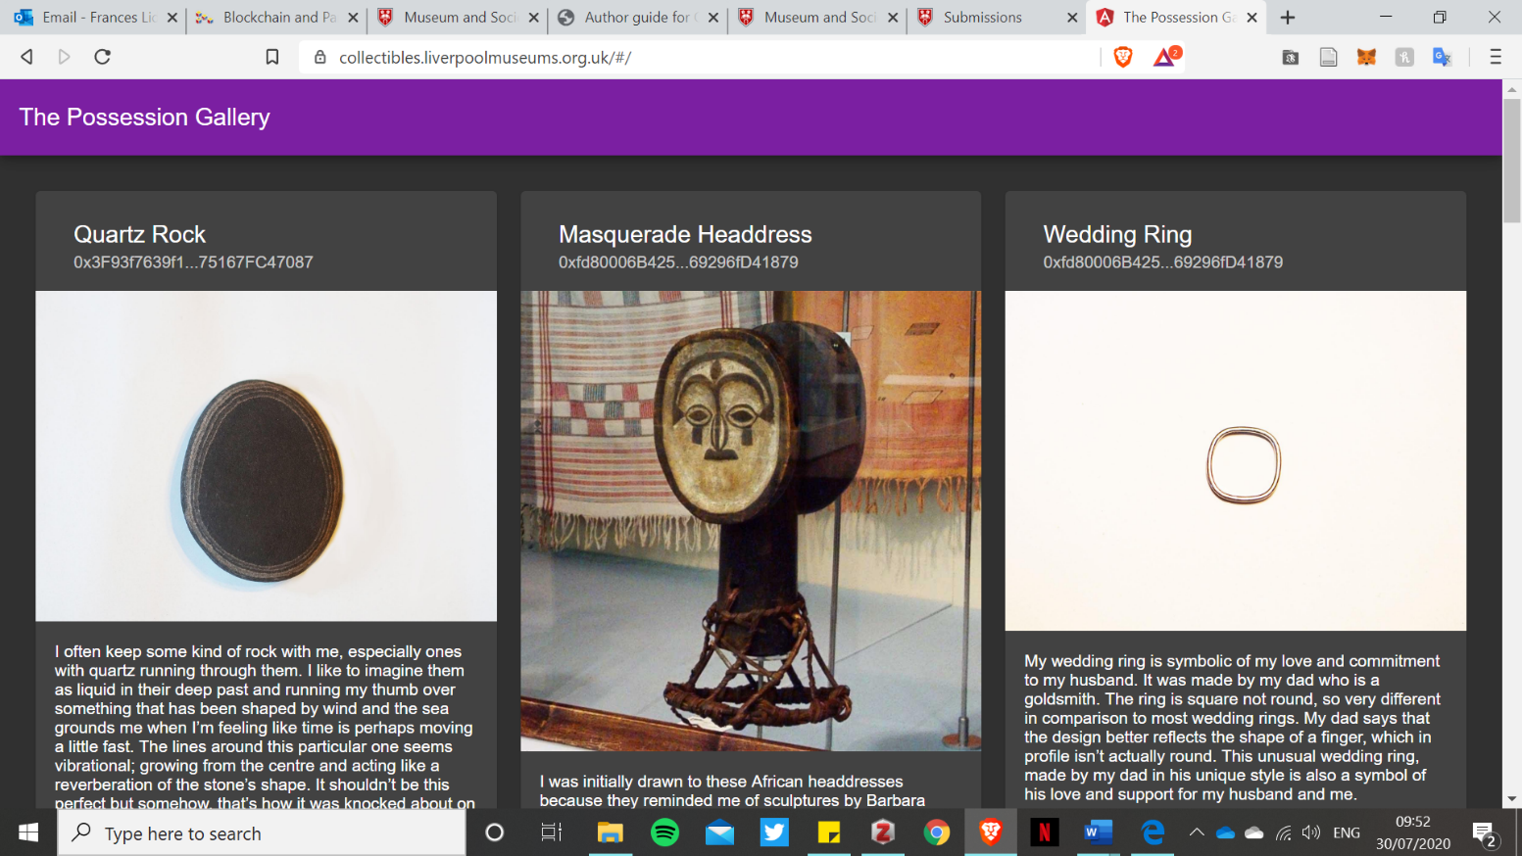

Figure 2 The Possession Gallery, Liverpool Museums Website