**List of images**

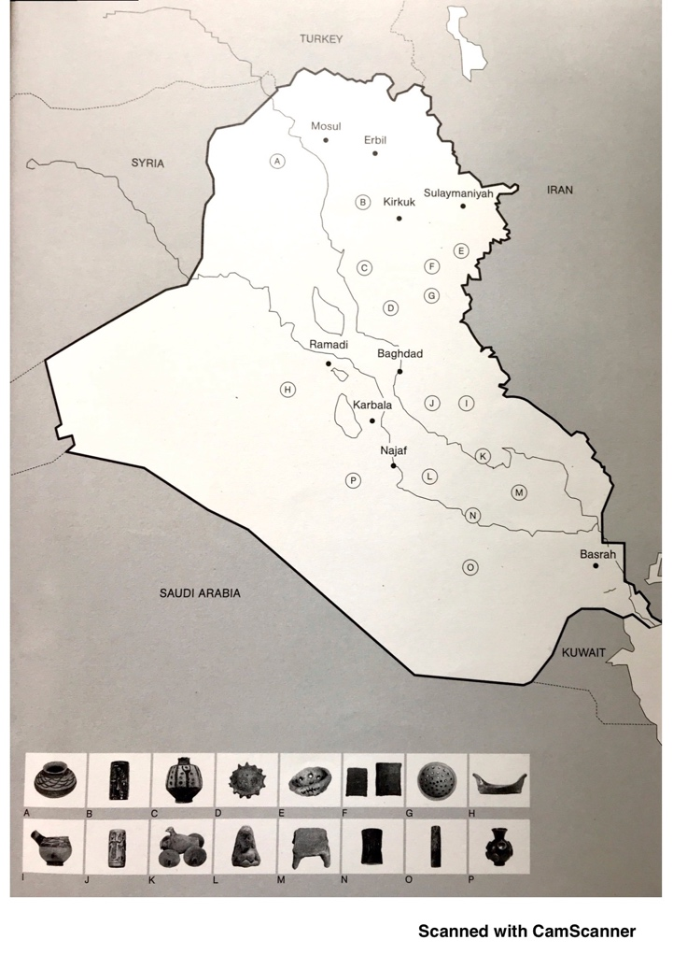

Figure 1. A map of Iraq showing excavation sites of the artefacts on display. The map is drawn from the accompanying publication to Archaic, the national pavilion of Iraq (Colombo & Chalabi, 2017, p. 19).

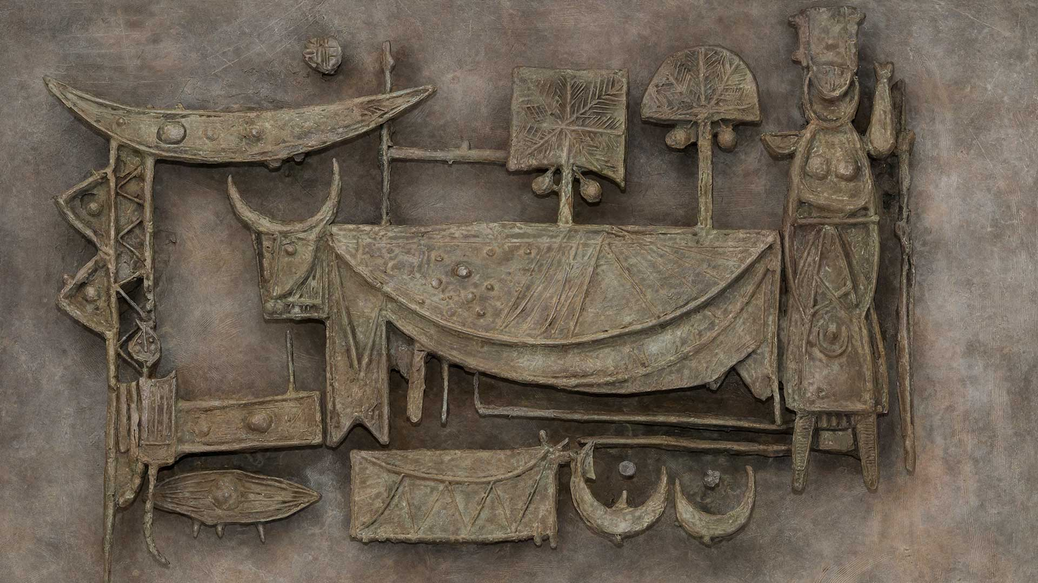

Figure 2. Jewad Selim, Pastoral. Bronze relief made from the plaster maquette created in 1955. Courtesy of the Family of Mohamed Makiya and Ruya Foundation.

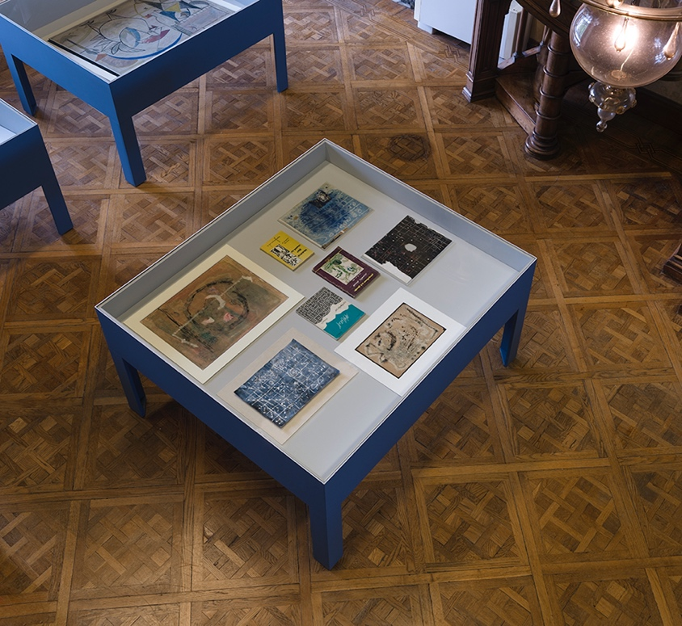

Figure 3. Vitrine with works by Shakir Hassan Al Said at the Archaic. Courtesy Ruya Foundation.

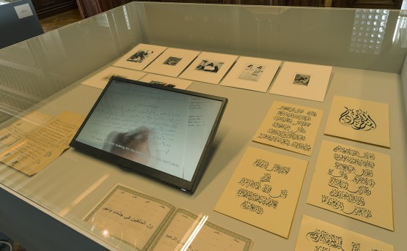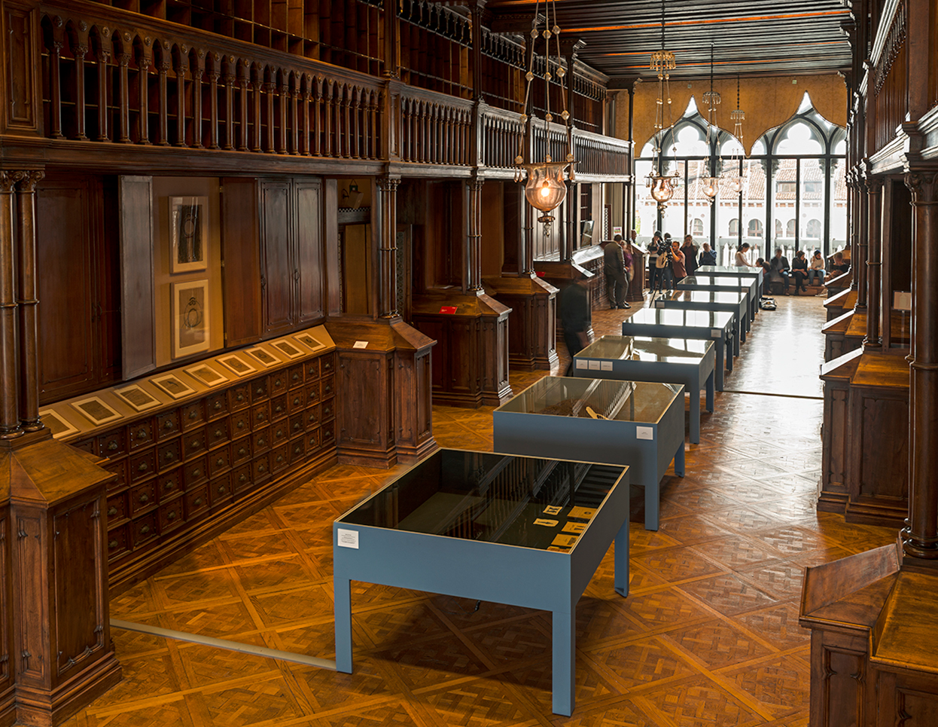

Figure 5. Archaic (2017), view of the vitrine containing Luya Fadhil's 'Scribe'. Courtesy of Ruya Foundation.

Figure 4. Archaic (2017), exhibition view. Photo: Courtesy of the Ruya Foundation.

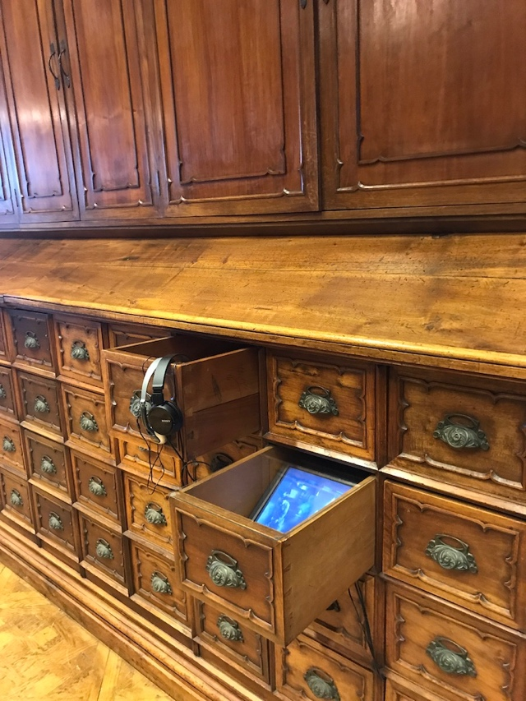

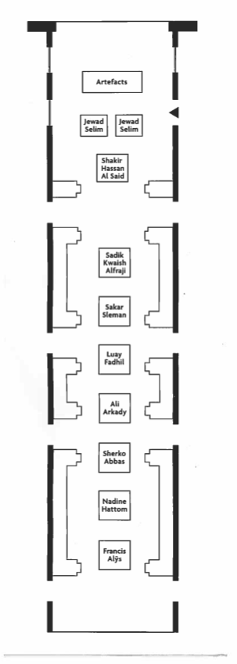

Figure 7. Exhibition plan from the exhibition brochure. A little black arrow at the top of the plan marks the entrance and exit to the pavilion. Courtesy of Ruya Foundation.

Figure 6. Archaic (2017). A tablet showing a documentary about Jewad Selim's 'Monument of Freedom'.

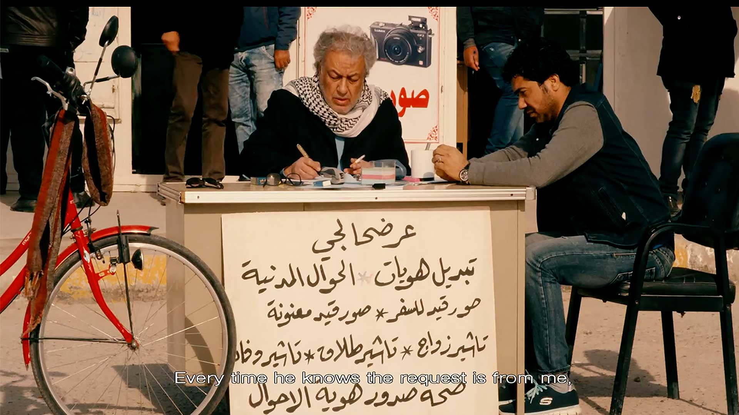

Figure 8. Luya Fadhil, Scribe, 2017, still.

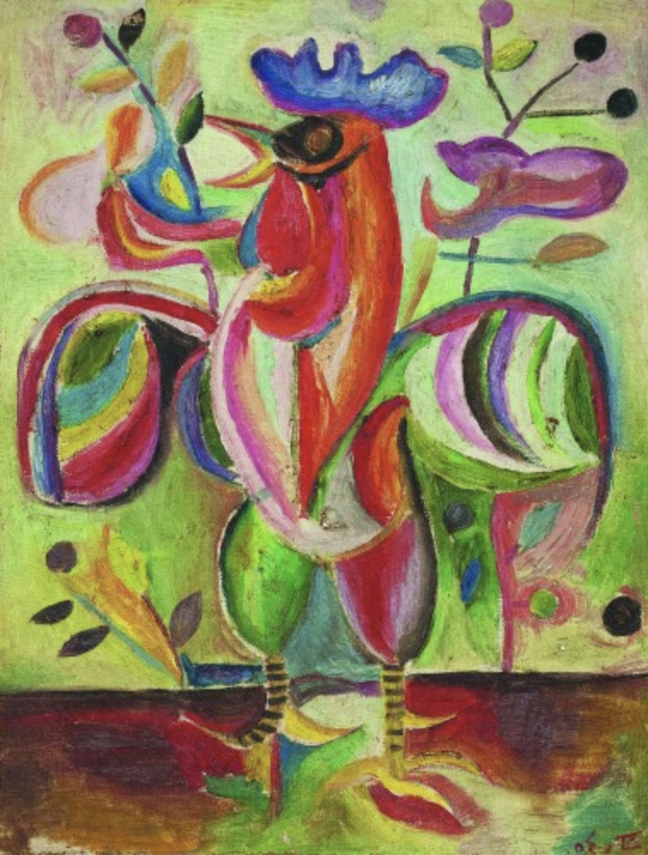

Figure 9. Shakir Hassan Al Said, The Articulate Cockerel, 1954. Courtesy of the Barjeel Art Foundation.

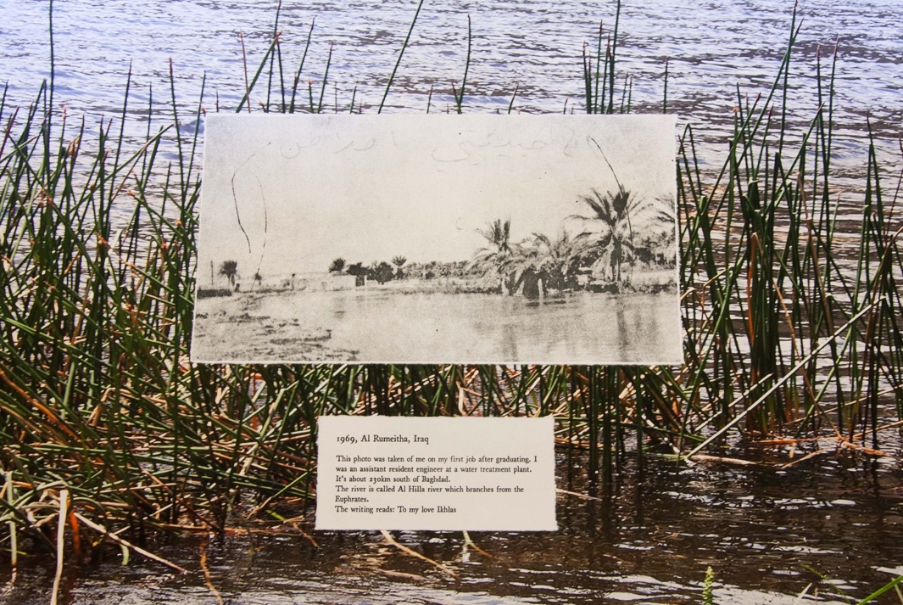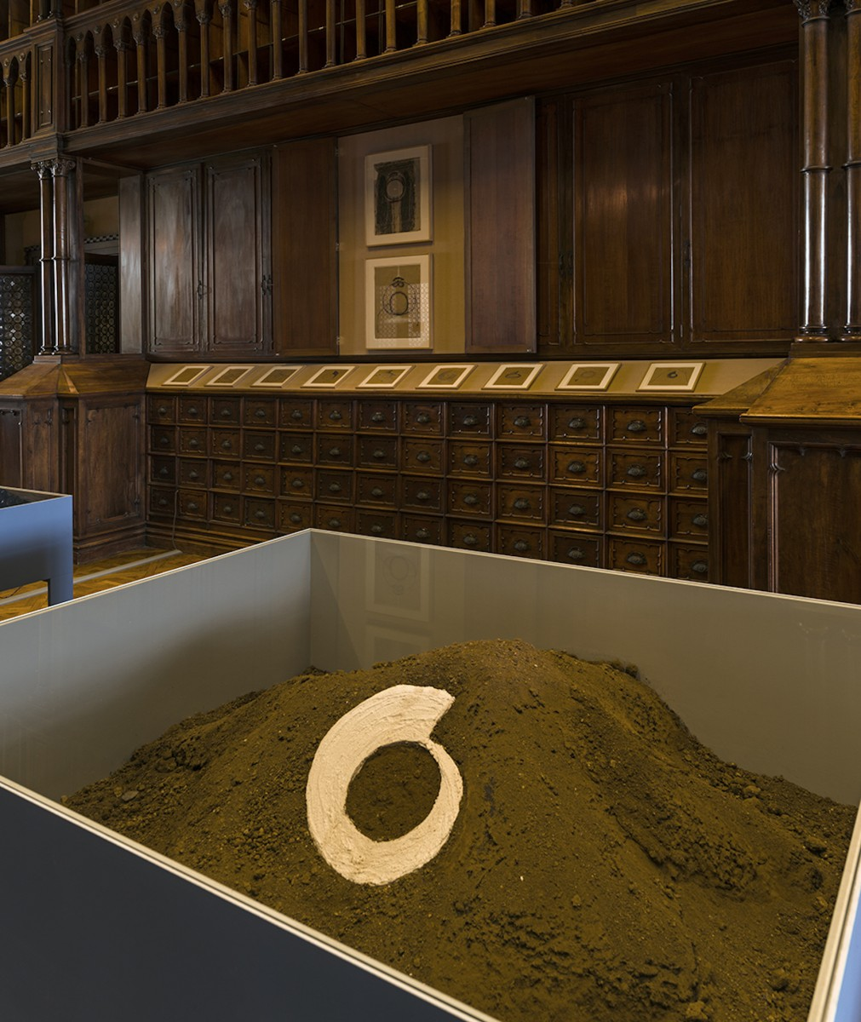

Figure 11. Nadine Hattom, Until the River Winds Ninety Degrees West, 2017, installation detail.

Figure 10. Sakar Sleman. Installation view, 2017. Courtesy of the artist and Ruya Foundation.