**List of images**

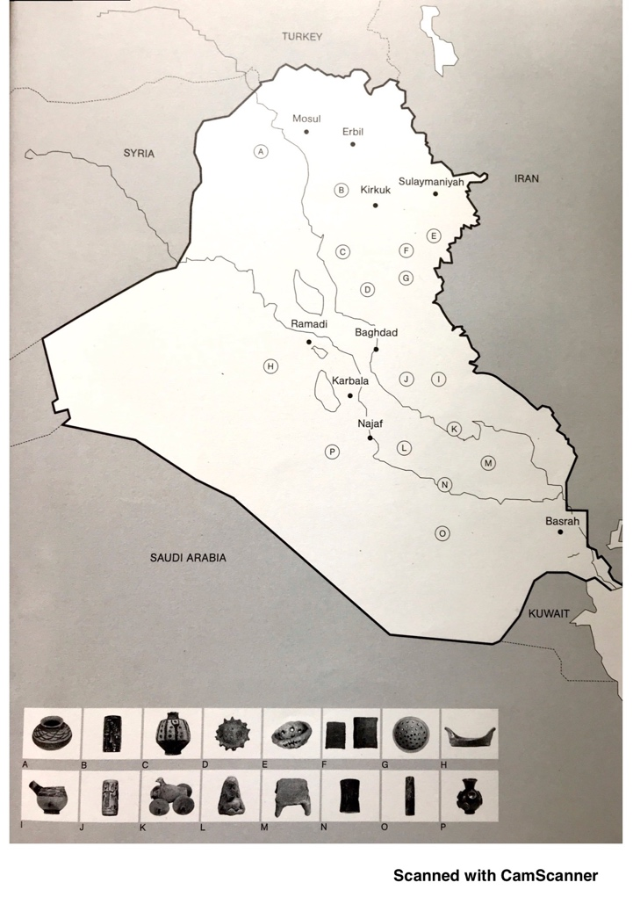

Figure 1. A map of Iraq showing excavation sites of the artefacts on display. The map is drawn from the accompanying publication to Archaic, the national pavilion of Iraq (Colombo & Chalabi, 2017, p. 19).

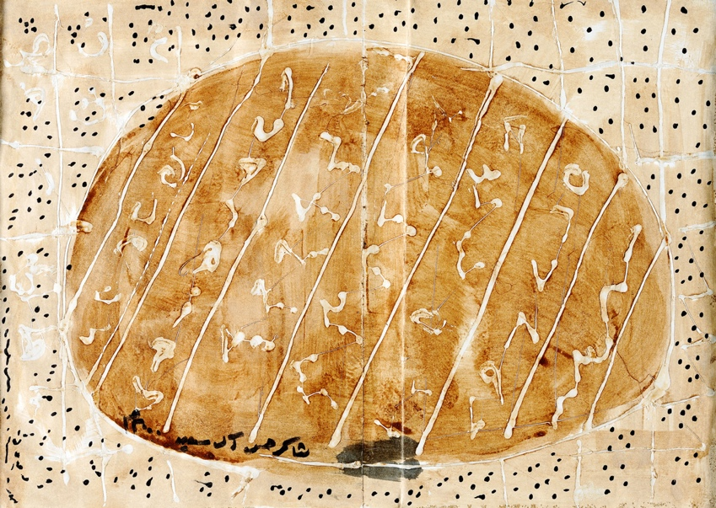

Figure 2. Shakir Hassan Al Said, Untitled, ca.1960. Courtesy of Agial Art Gallery and Ruya Foundation.

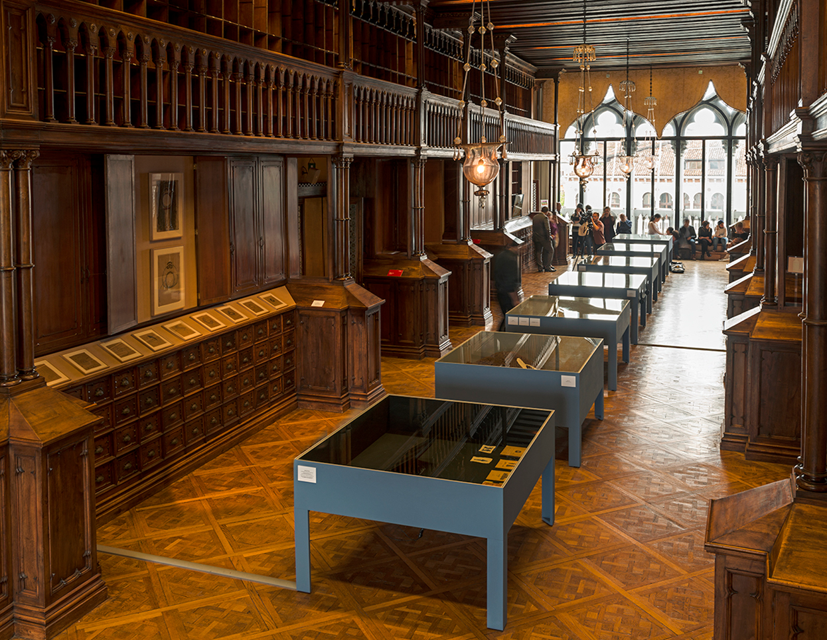

Figure 3. Archaic (2017), exhibition view. Photo: Courtesy of the Ruya Foundation.

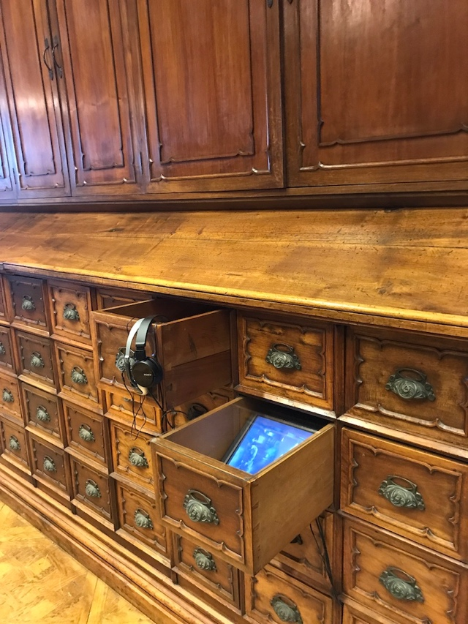

Figure 4. Archaic (2017). A tablet showing a documentary about Jewad Selim's 'Monument of Freedom'.

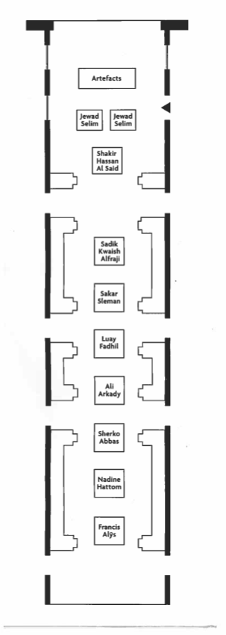

Figure 5. Exhibition plan from the exhibition brochure. A little black arrow at the top of the plan marks the entrance and exit to the pavilion. Courtesy of Ruya Foundation.

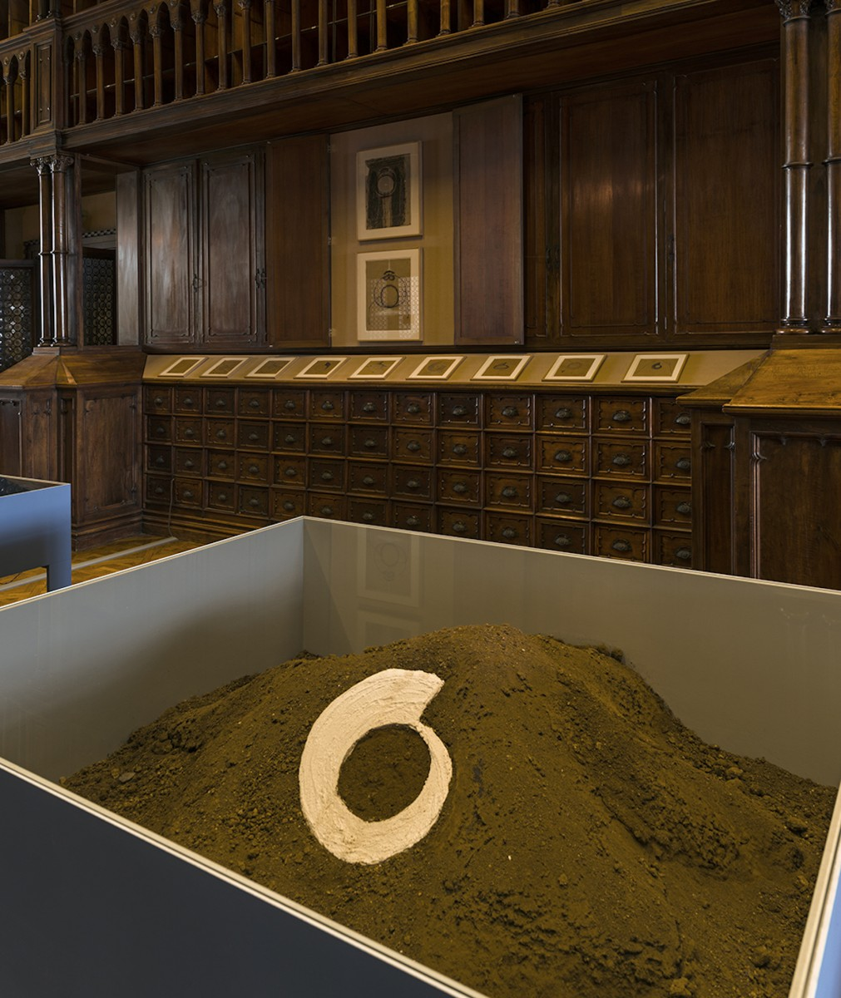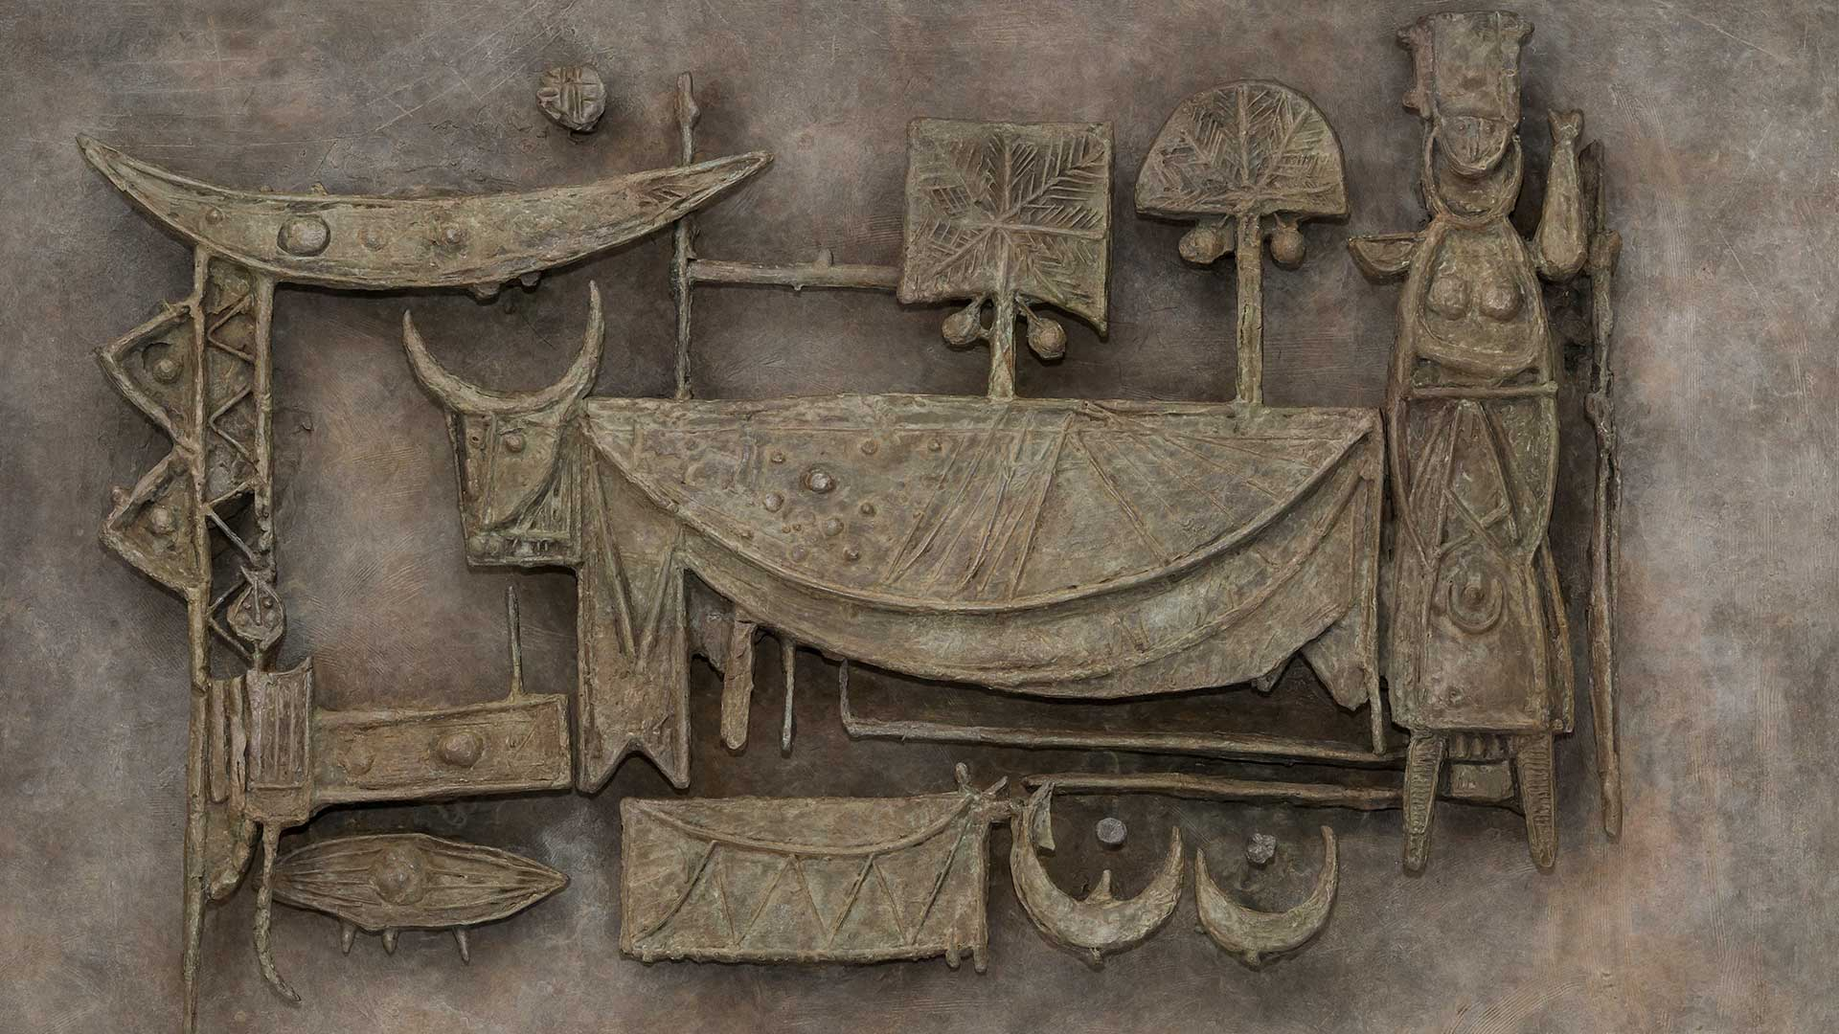

Figure 7. Sakar Sleman. Installation view, 2017. Courtesy of the artist and Ruya Foundation.

Figure 6. Jewad Selim, Pastoral. Bronze relief made from the plaster maquette created in 1955. Courtesy of the Family of Mohamed Makiya and Ruya Foundation.

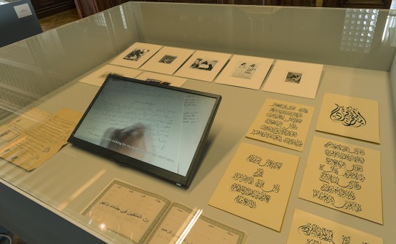

Figure 8. Archaic (2017), view of the vitrine containing Luya Fadhil's 'Scribe'. Courtesy of Ruya Foundation.

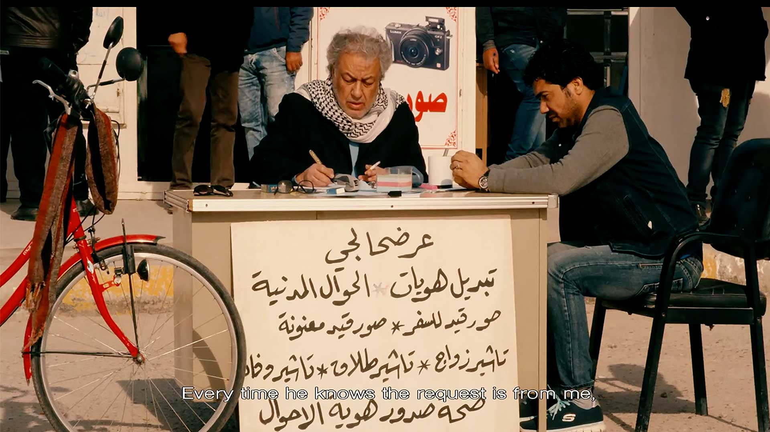

Figure 9. Luya Fadhil, 'The Scribe', 2017, still.

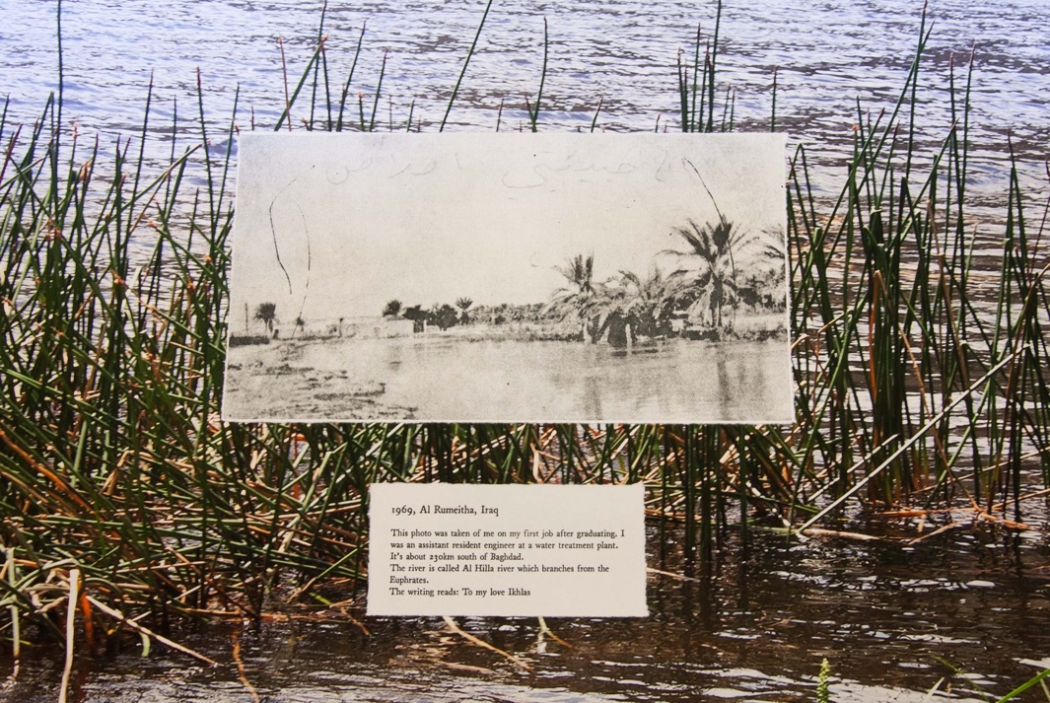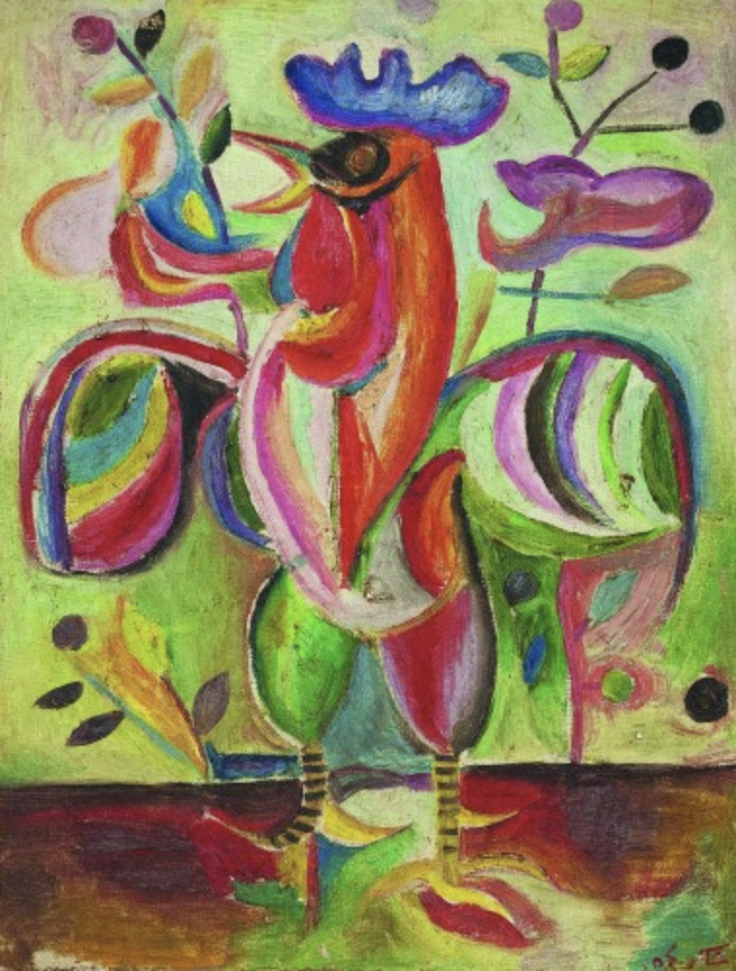

Figure 11. Nadine Hattom, 'Until the River Winds Ninety Degrees West', 2017, installation detail.

Figure 10. Shakir Hassan Al Said, The Articulate Cockerel, 1954. Courtesy of the Barjeel Art Foundation.