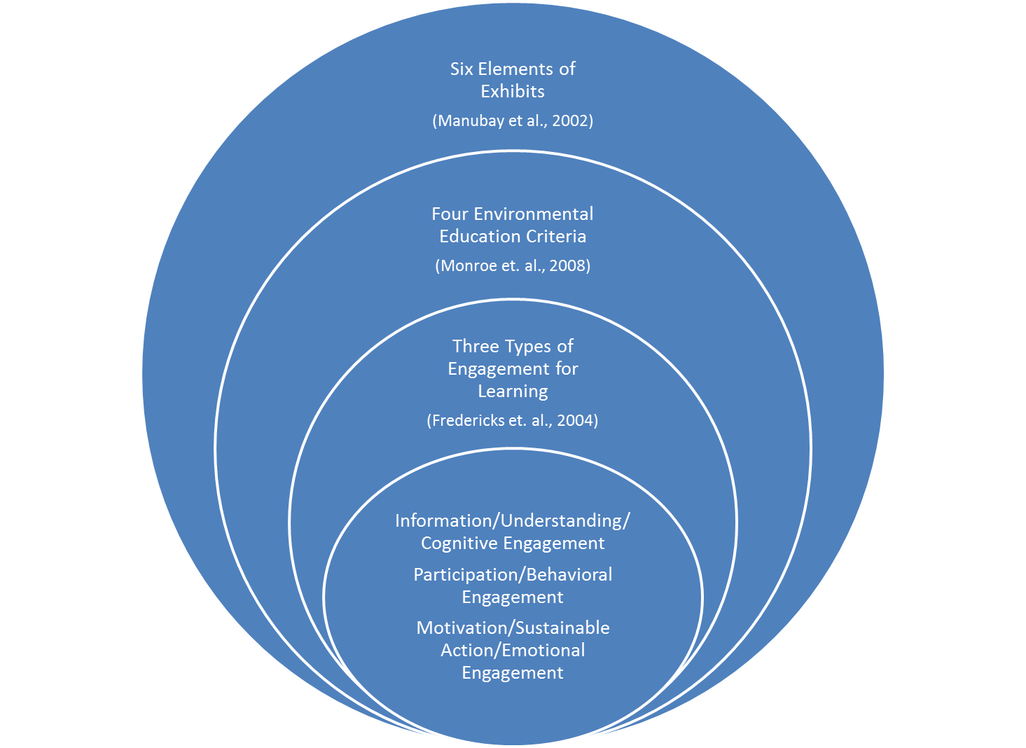

Figure 1: Framework Venn Diagram