FIGURES FOR PERMANENT EXHIBIT PAPER
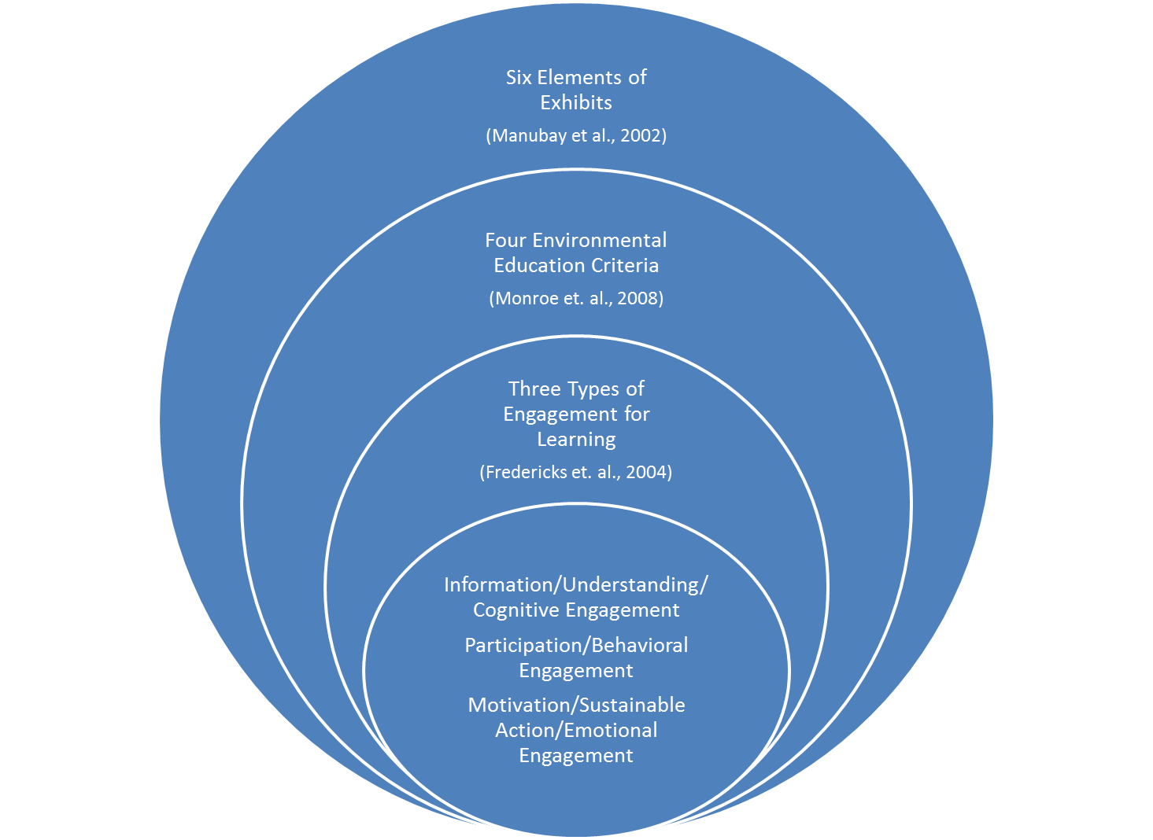
Figure 1: Framework Venn Diagram
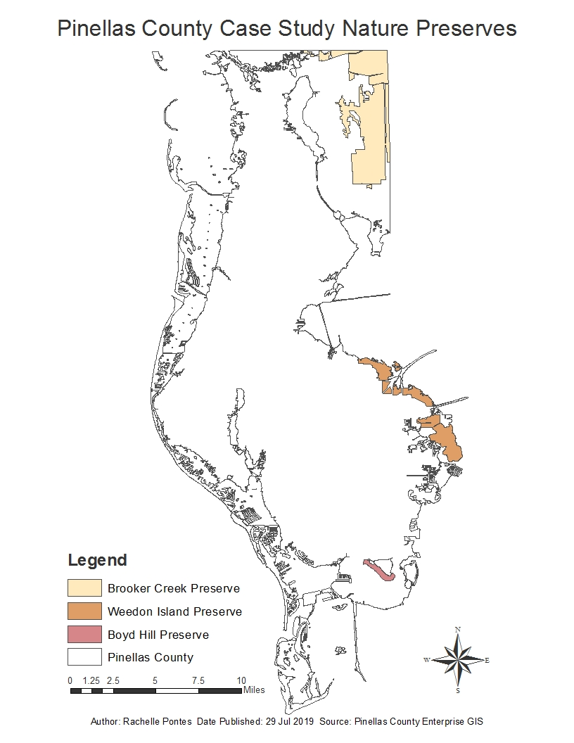
Figure 2: Study Site Map
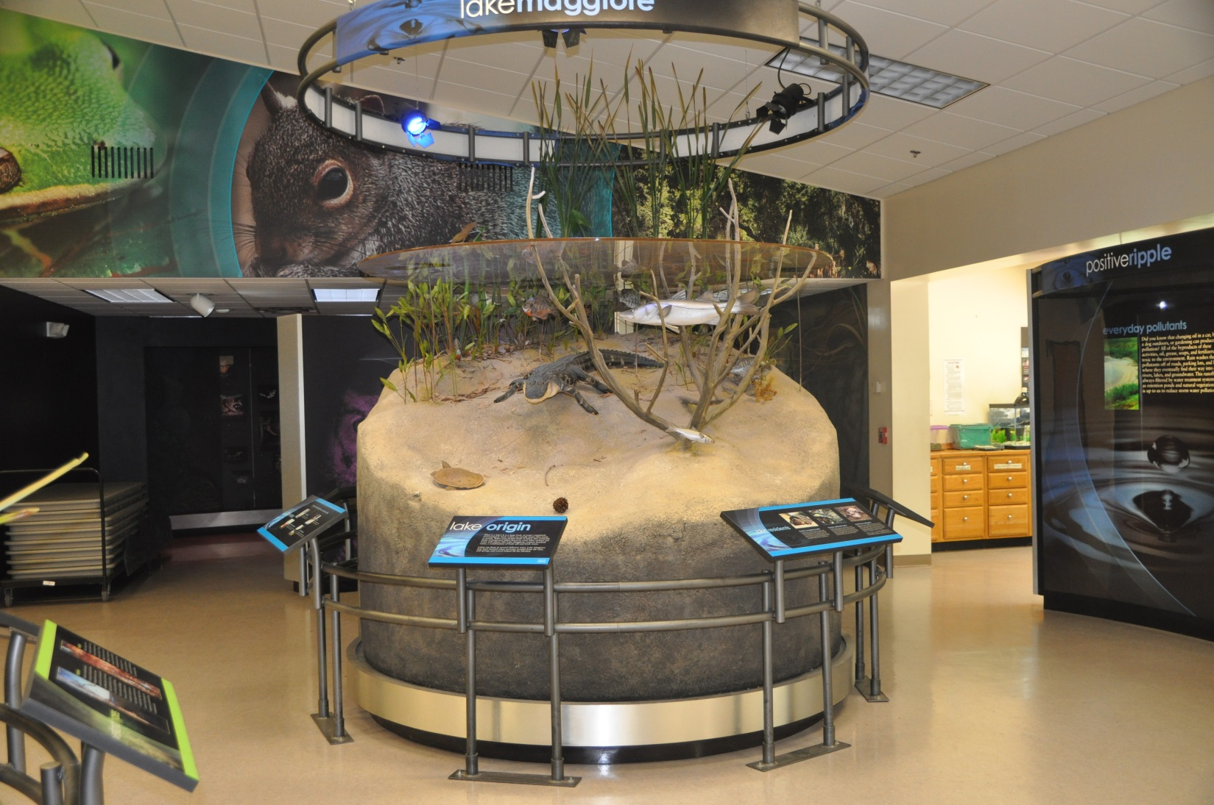
Figure 3: Boyd Hill Exhibit
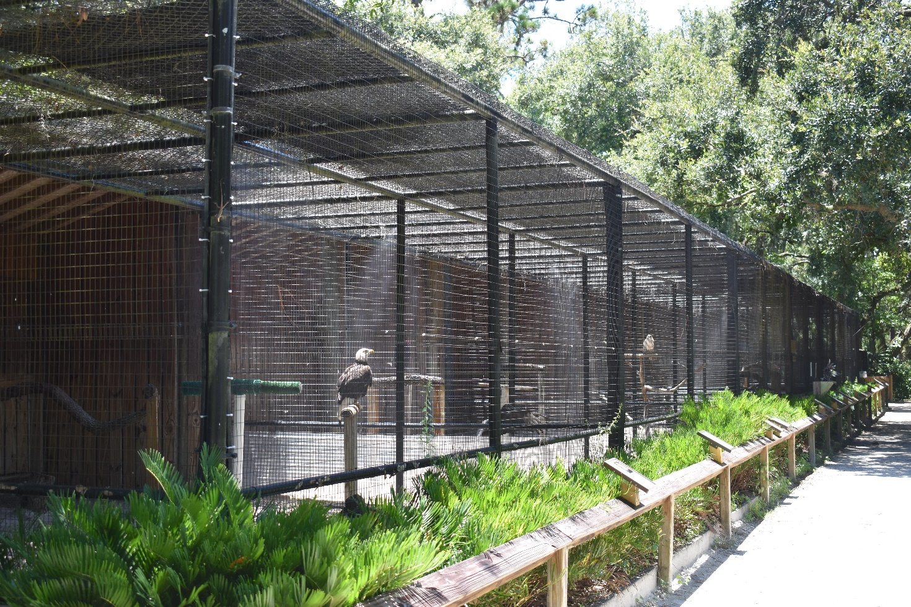
Figure 4: Boyd Hill Aviary
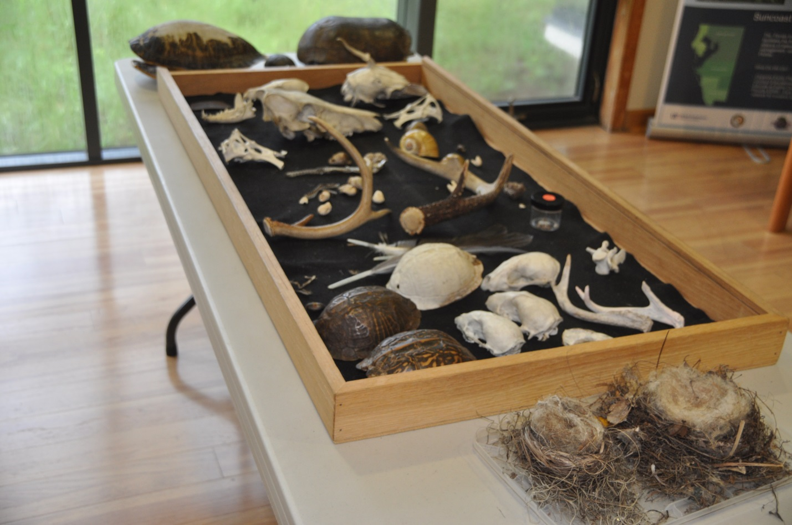
Figure 5: Animal Remnant Touch Table
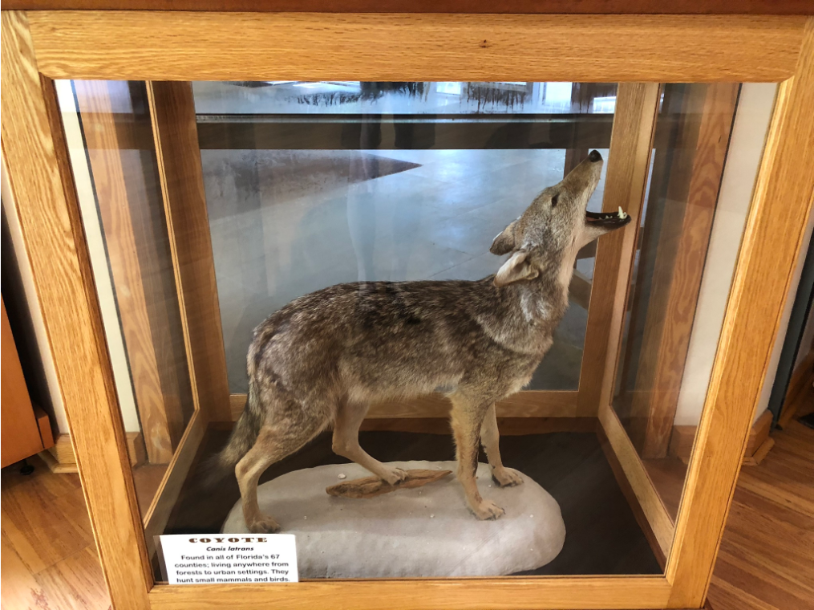
Figure 6: Taxidermy of Coyote

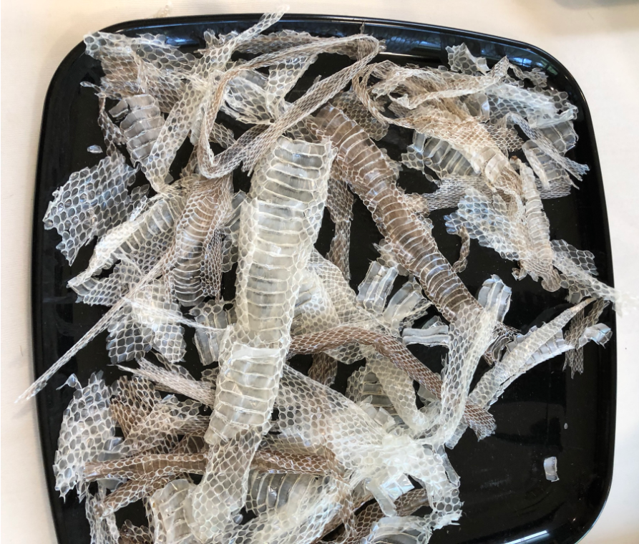
Figure 7: Snake Molts

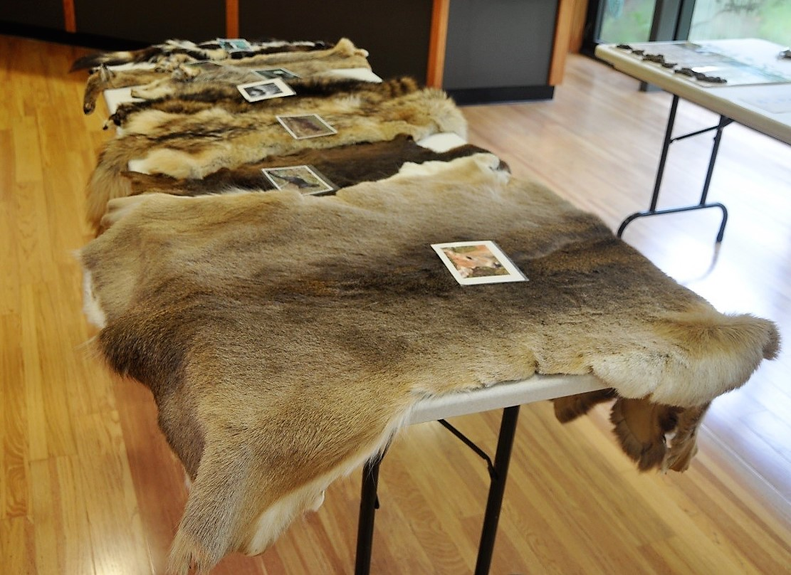
Figure 8: Animal Skins Touch Table

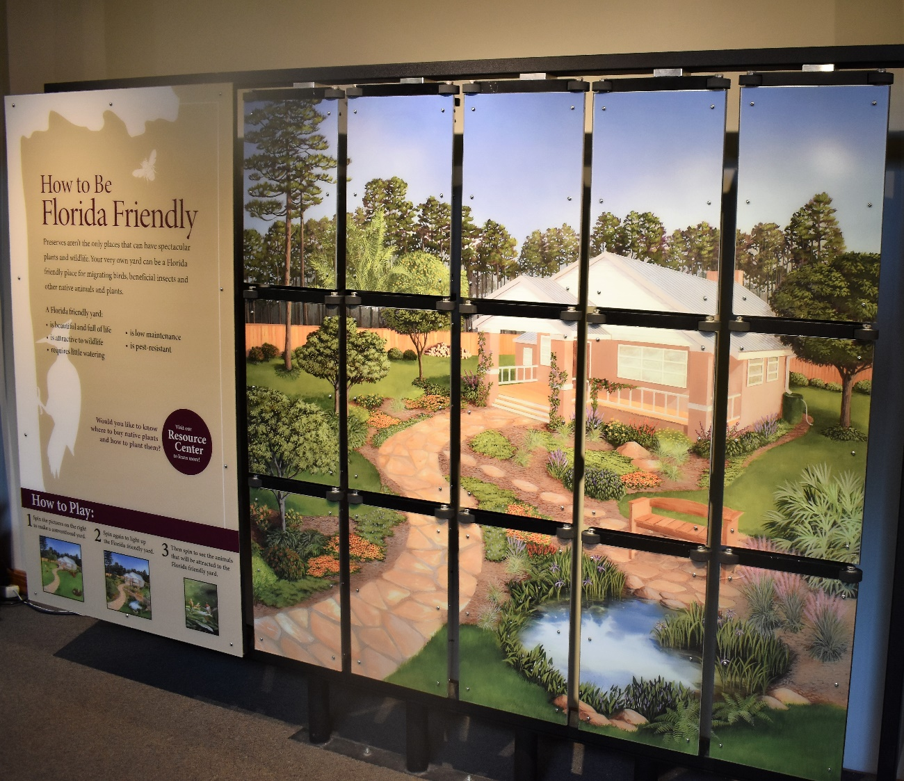
Figure 9: Interactive Florida Friendly Landscaping Wall Display
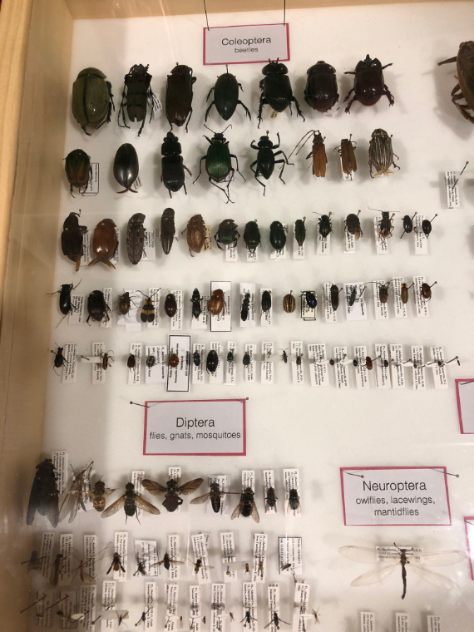
Figure 10: Entomology Display

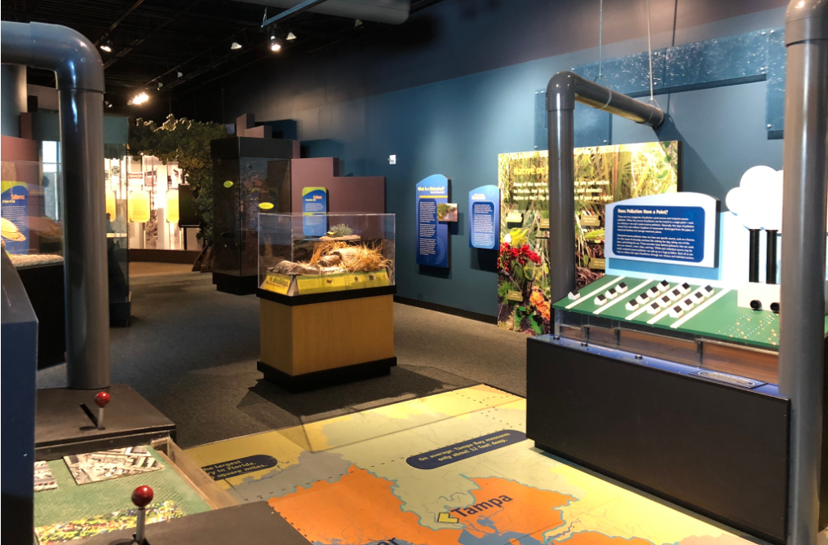
Figure 11: Weedon Island Exhibit
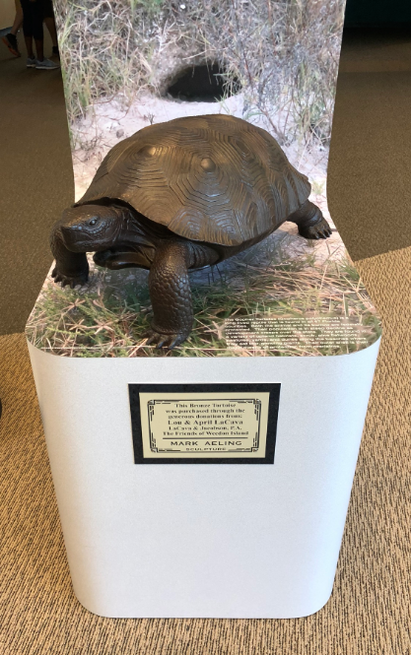
Figure 10: Gopher Tortoise at Weedon Island

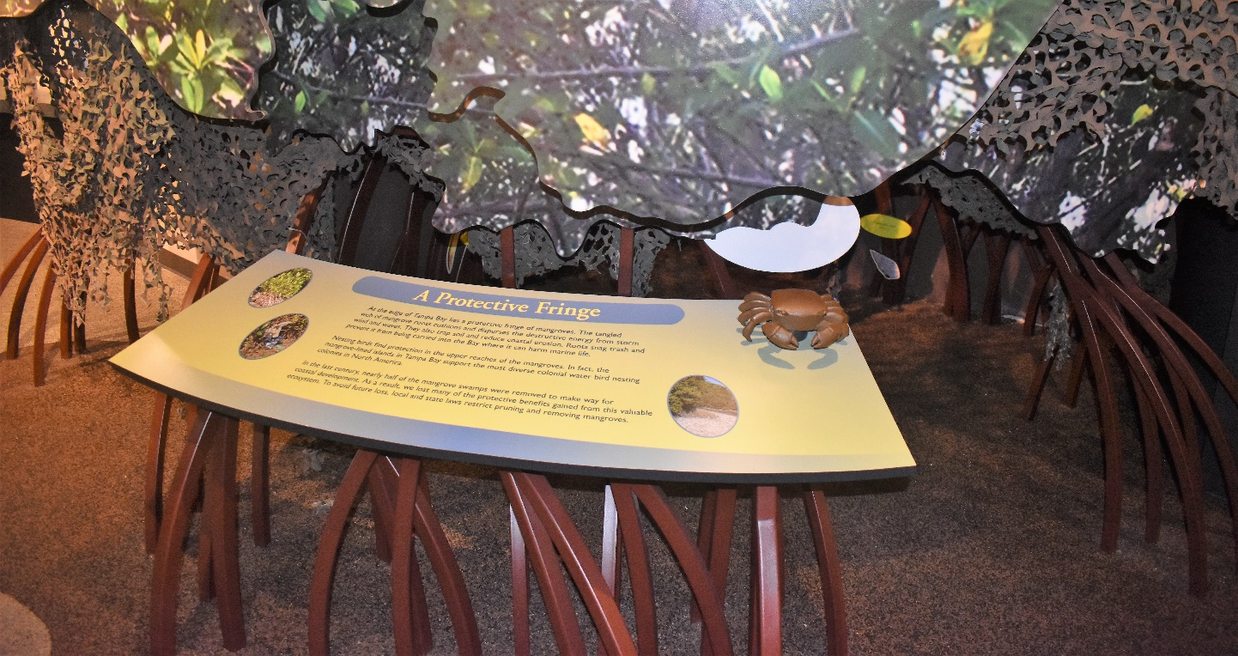
Figure 13: Mangrove Display at Weedon Island

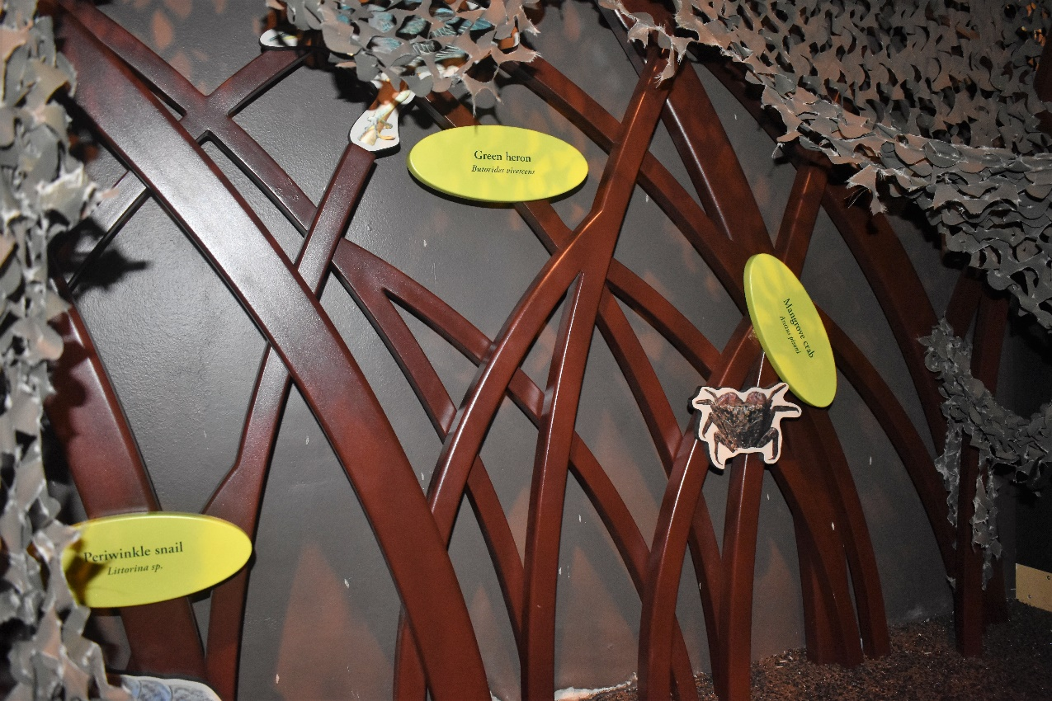
Figure 14: Inside the Mangrove Display at Weedon Island
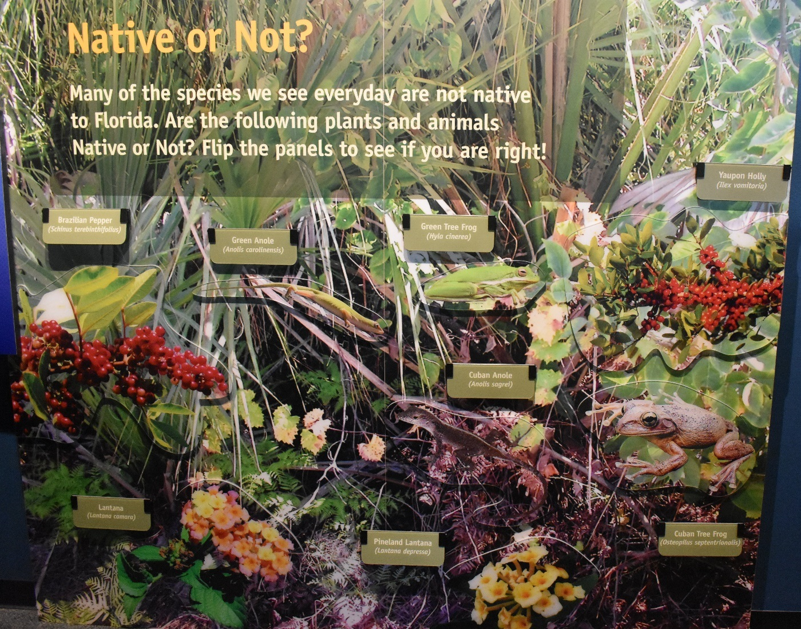
Figure 15: Native and Non-Native Plants Display
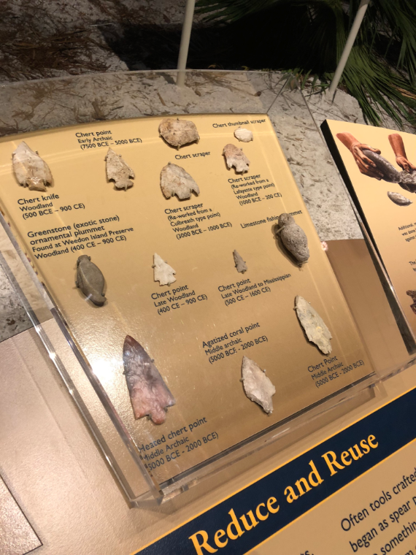
Figure 16: Arrowhead Display
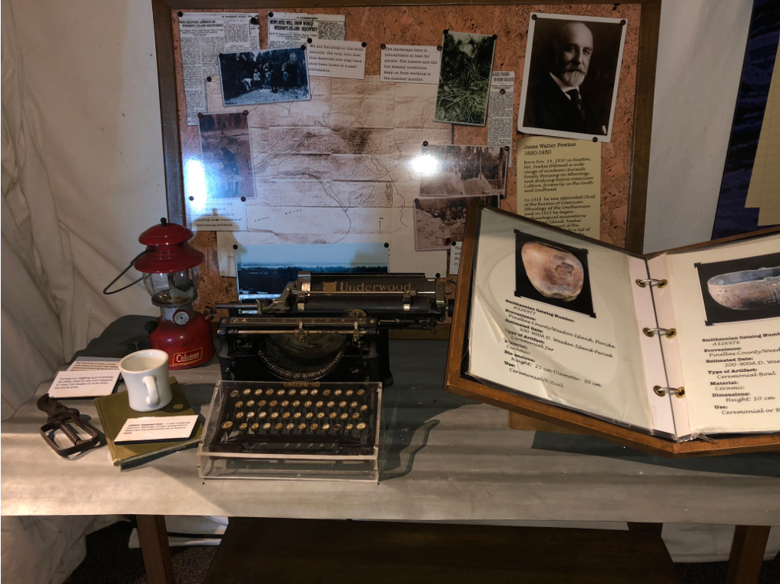
Figure 17: Archaeological Artifact Display

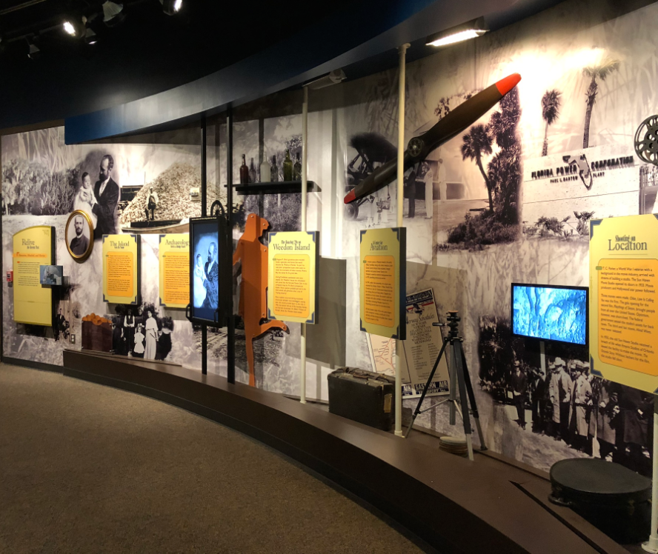
Figure 18: History of Human Uses of Weedon Island

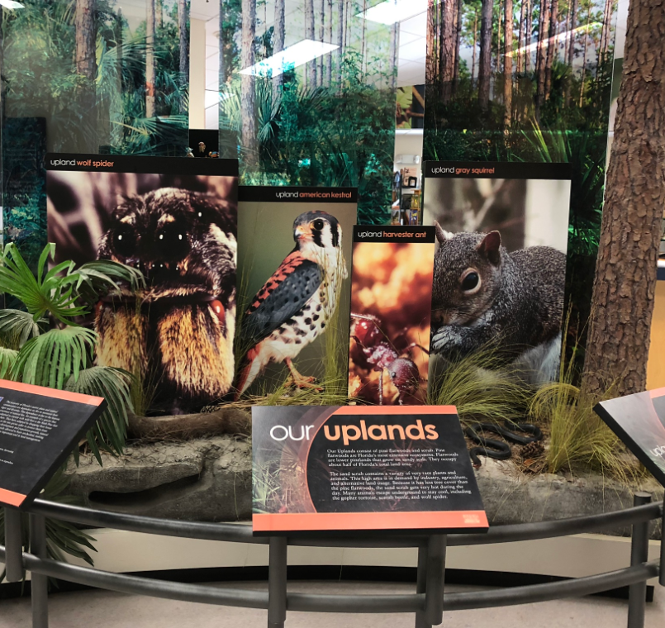
Figure 19: Visual and Textual Displays

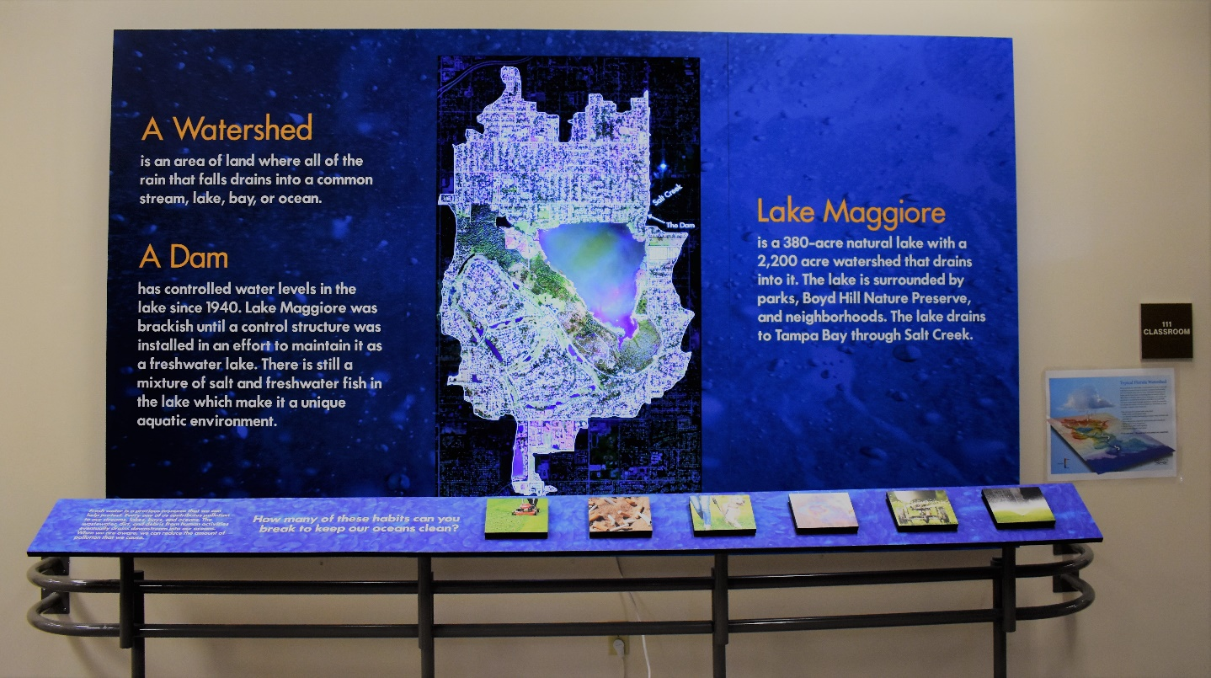
Figure 20: Interactive Box Display

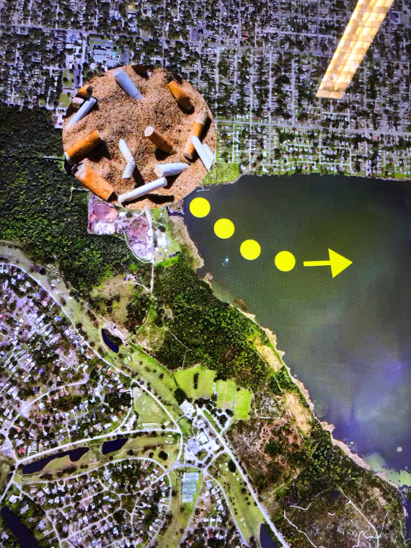
Figure 21: GIS Map with Interactive Box Display
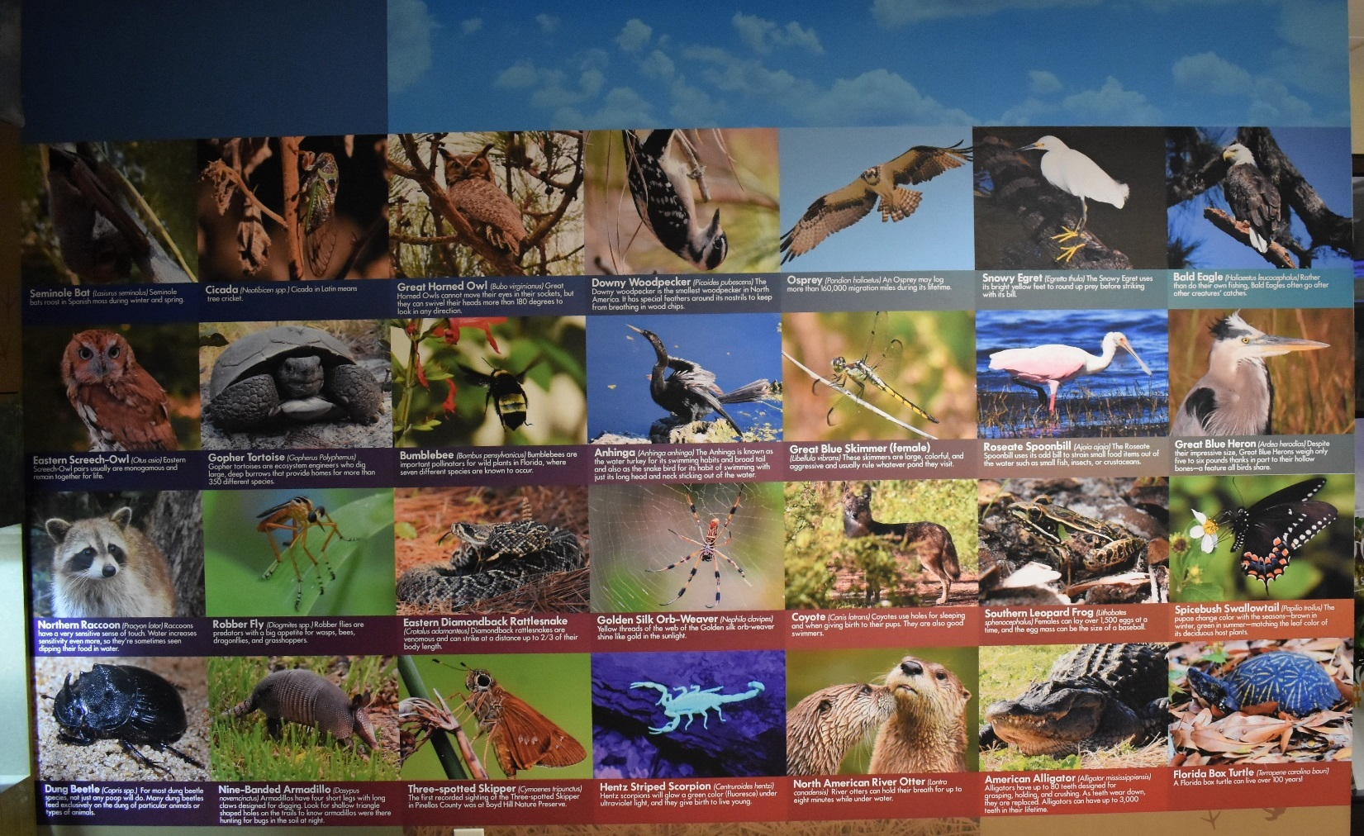
Figure 22: Animal Exhibit Wall

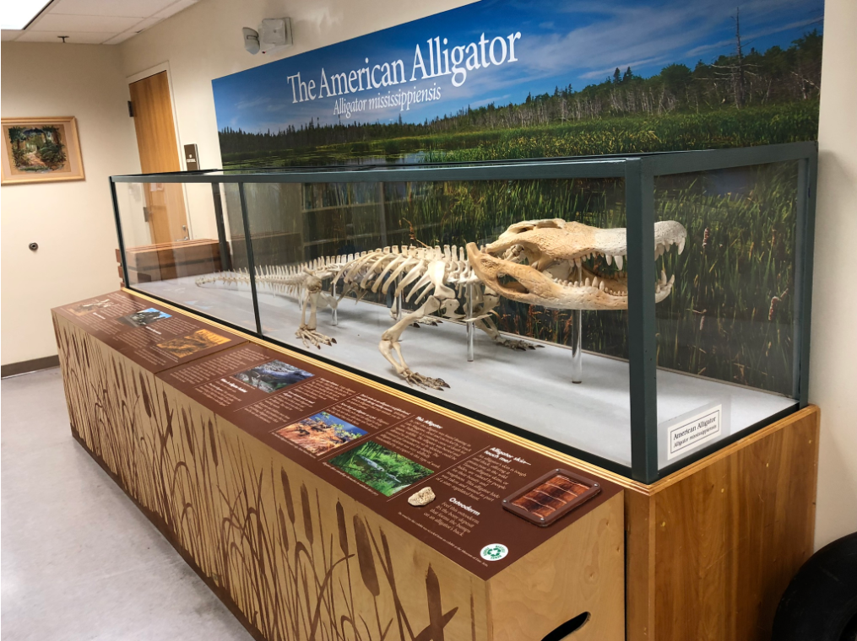
Figure 23: Fourteen Foot Alligator Skeleton
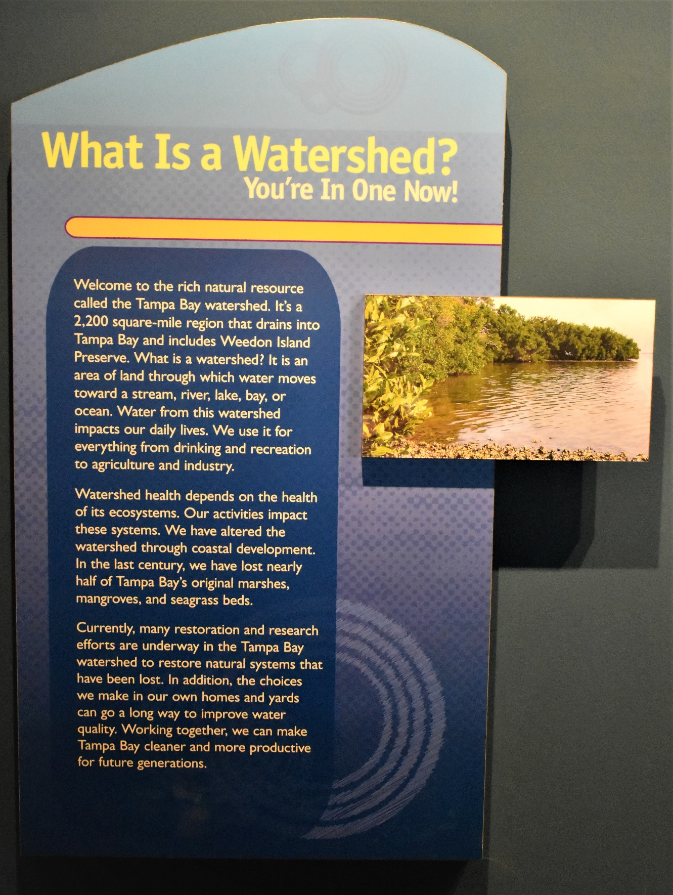
Figure 24: Textual Display on Watersheds

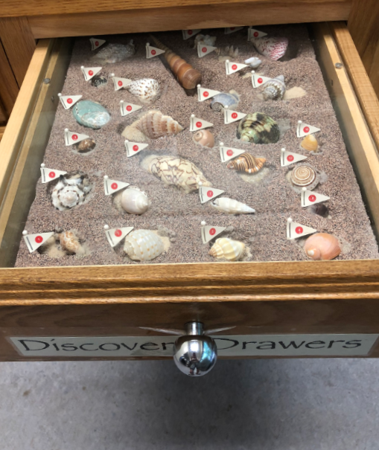
Figure 25: Discovery Drawer

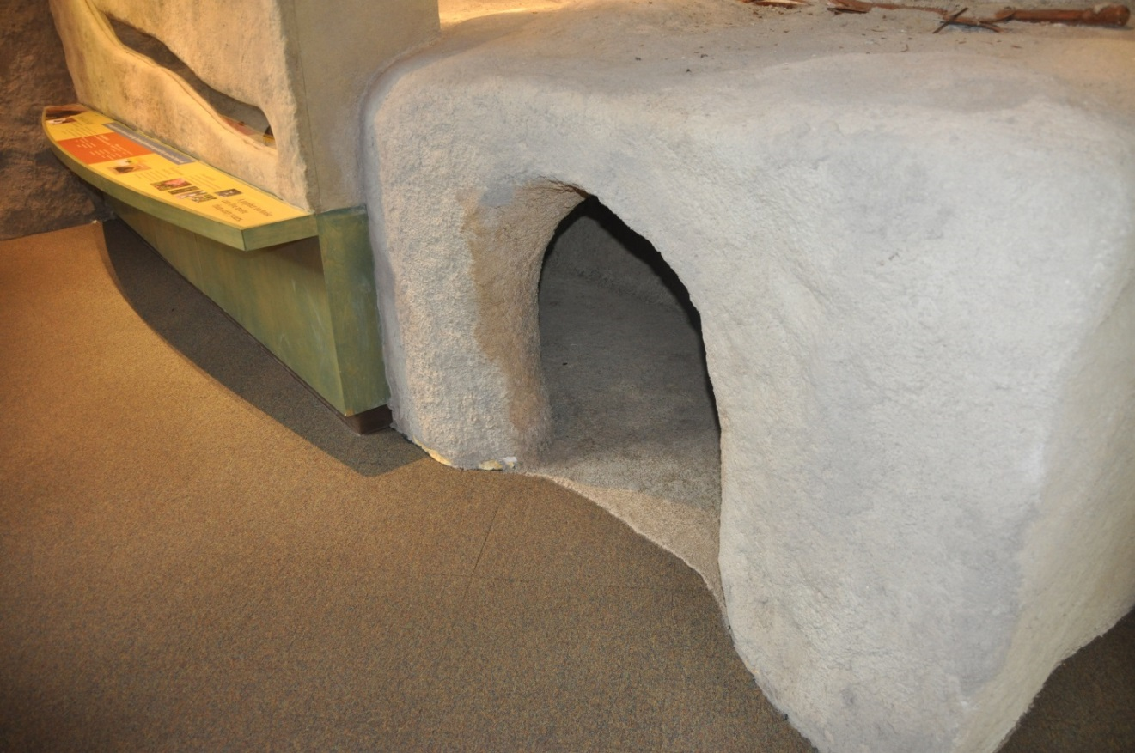
Figure 26: Interactive Gopher Tortoise Burrow Display

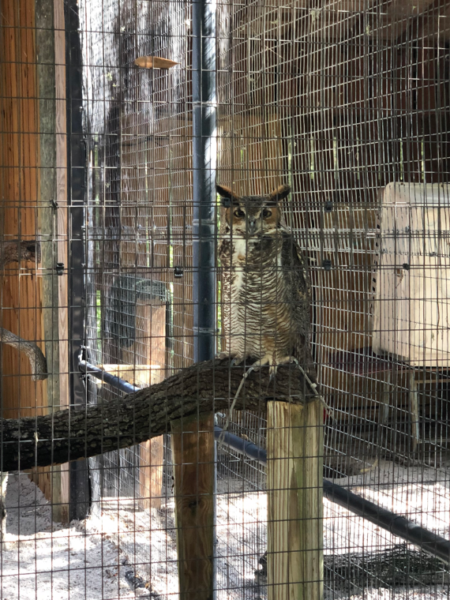
Figure 27: Live Animal Exhibit

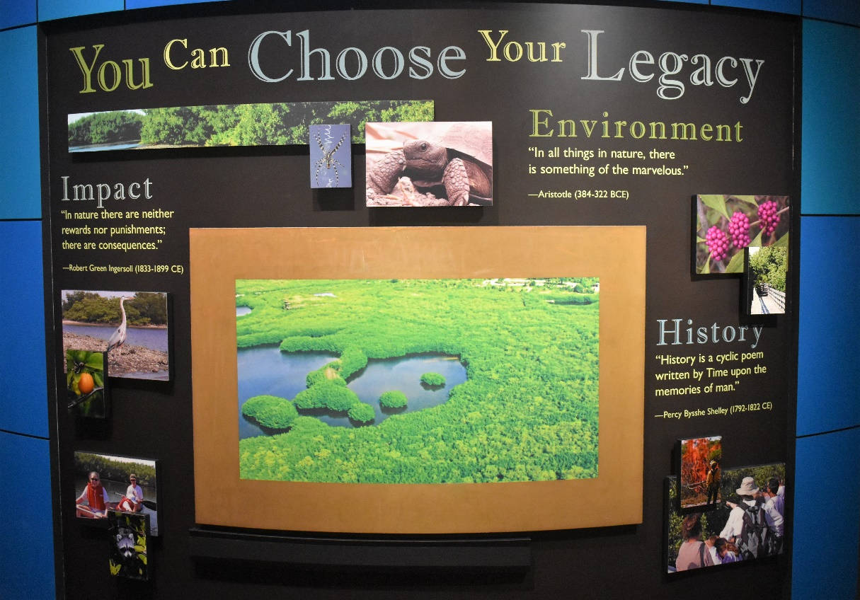
Figure 28: Inspirational Messaging Weedon Island

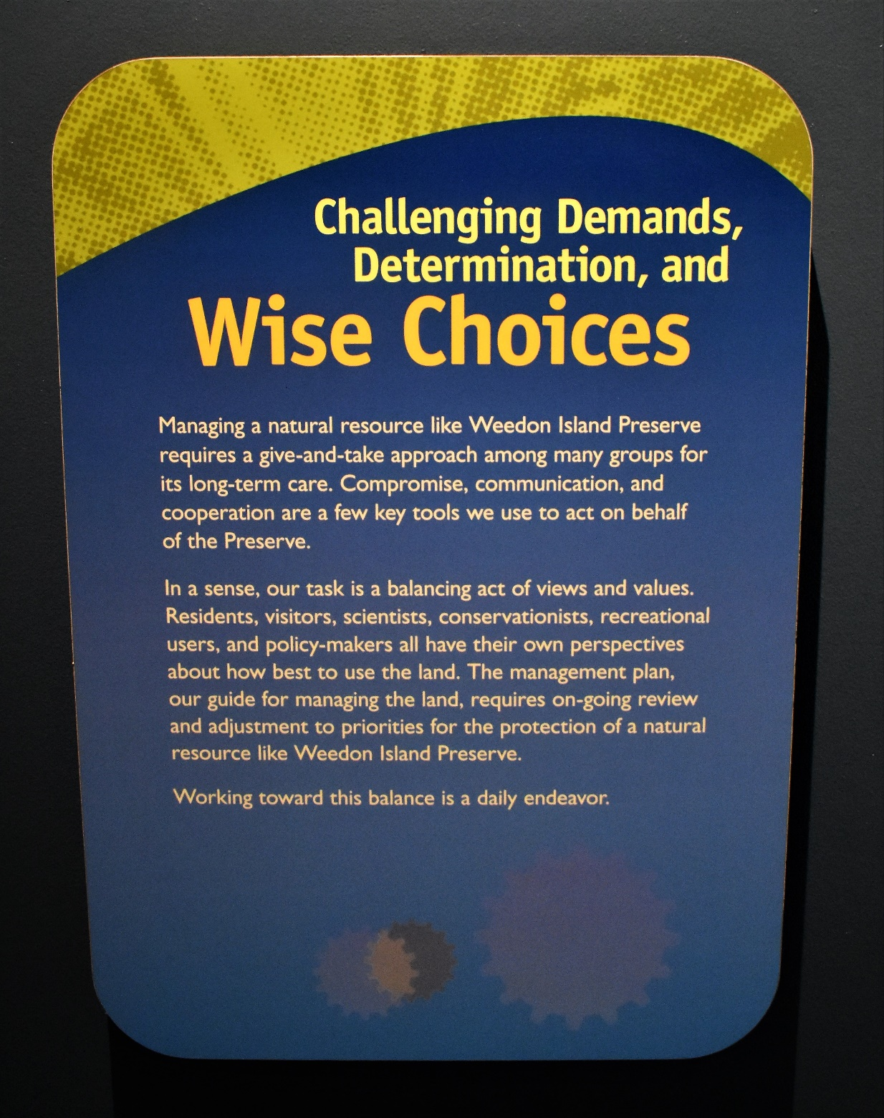
Figure 29: Collaborative Management

