**Author**

**“Making Fun of the Museum” – Museum and Society**

**FIGURES**

Fig 1 Gerald McMaster, Installation view of the first room of *Savage Graces*, Ottawa Art Gallery, 1994.

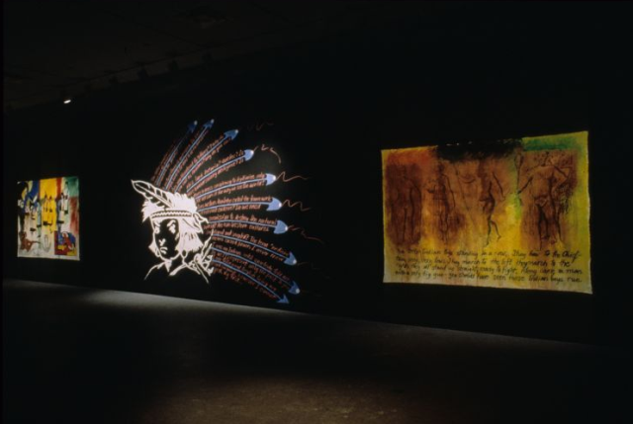

Fig 2 The Museum of Jurassic Technology, Los Angeles (photo: Jennifer Bastian) [CC BY-SA 3.0] Photo: Wikipedia Commons

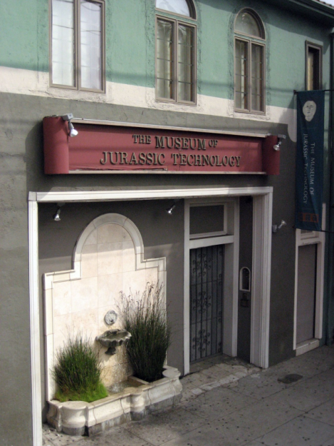

Fig 3 *Grover and the Everything in the Whole Wide World Museum* (title pages)

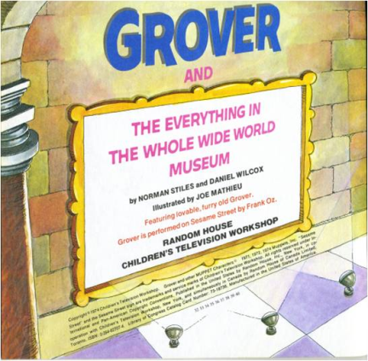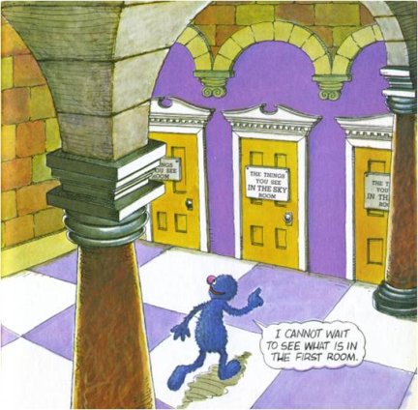

Fig 4 The Tall Hall, from *Grover and the Everything in the Whole Wide World Museum*

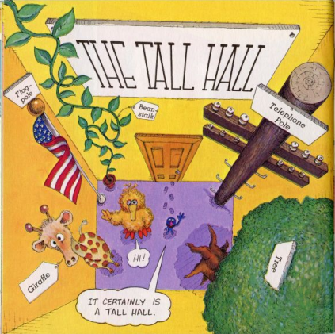

Fig 5 M. Ezra and E. Ezra, Cover, *We go to the gallery*

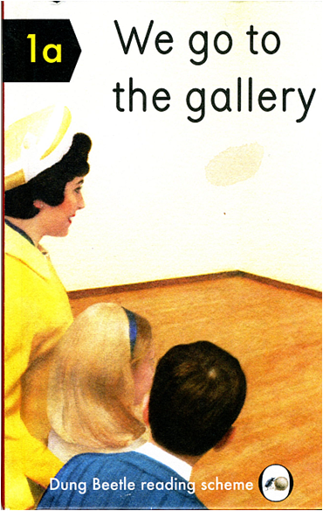

Fig 6 ‘The Death of Meaning’, *We go to the gallery*

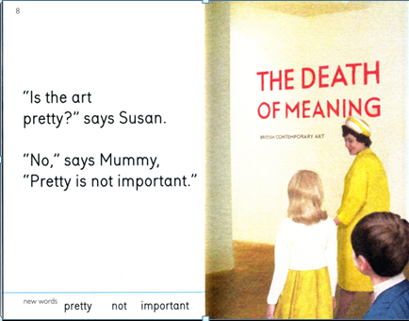

Fig 7 Entrance to Wonderkamers, Gemeentemuseum, The Hague, 2019. Photo: author

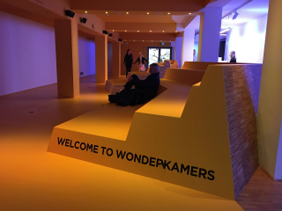

Fig 8 Entrance to Q?rius, United States National Museum of Natural History, Smithsonian Institution, Washington D.C., 2018. Photo: Author

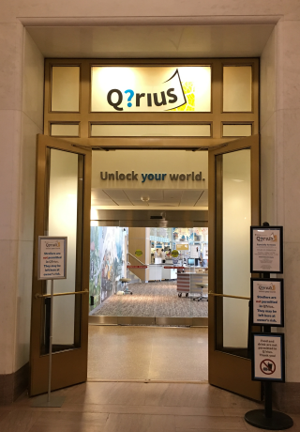

Fig 9 Recreated display of ethnographic curiosities dating to the seventeenth and eighteenth centuries, Bibliothèque Ste. Geneviève, Photo: Author, 2014

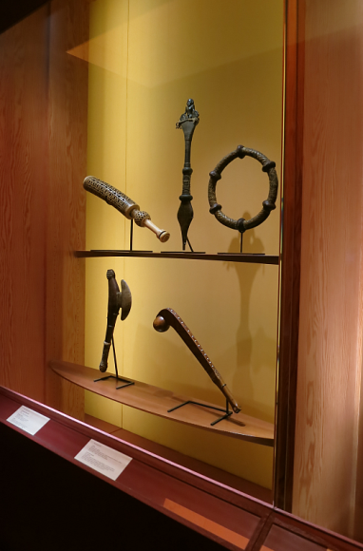

Fig10 Recreated display of natural curiosities, *Dans la chamber des merveilles*, Musée des Confluences, Photo: Author, 2016

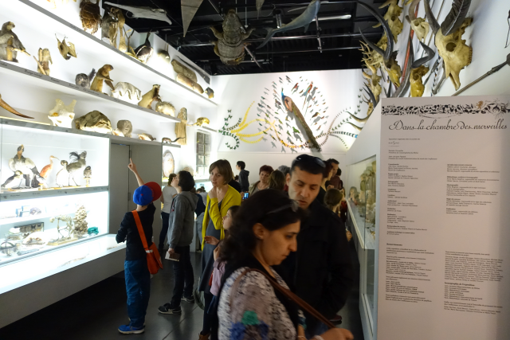  
Fig 11 Janet Echelman, *1.8 Renwick*, from the exhibition *Wonder*, Renwick Gallery, Smithsonian American Art Museum, Museum purchase made possible by the American Art Forum. © 2015 Janet Echelman. Photo by Ron Blunt

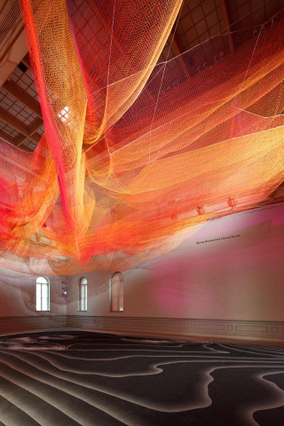

Fig 12 Introductory section, *Objects of Wonder* United States National Museum of Natural History, Smithsonian Institution. Photo: Author

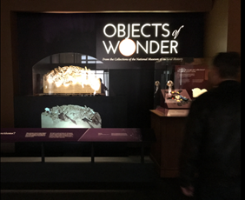

Fig 13 Shelley Niro, *Skywoman* (2001), First Peoples Hall, Canadian Museum of History, Ottawa

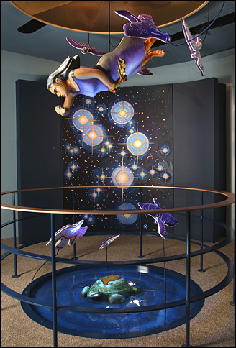

Fig 14 Indigenous and Canadian Galleries, National Gallery of Canada, 2017. Photo: Author

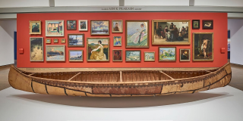

Fig 15 Sarah Stone, Interior of Leverian Museum, view as it appeared in the 1780s, c 1835, watercolour, The British Museum Am2006, Drg.54. AN246366001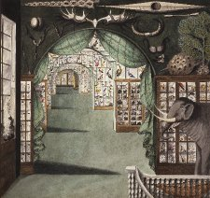

Fig 16 Drawing of the Dighton Rock petroglyphs, *The Philosophy Chamber*, Harvard Art Museums. Photo: Author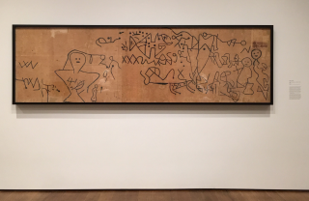

Fig 17 Installation view showing painted portraits, scientific instrument, natural history specimens, and a Hawaiian feather cloak (visible through the doorway), *The Philosophy Chamber*, Harvard Art Museums. Photo: Author

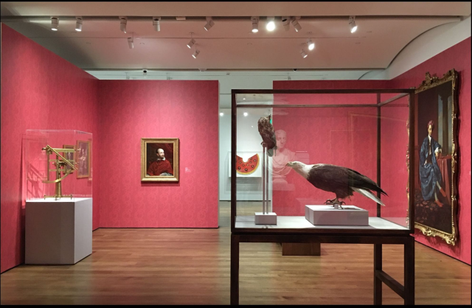

Fig 18 Advertisement for the Boston Museum from the Barre (Vermont) Patriot, 15 September 1850, Photo: Wikipedia Commons

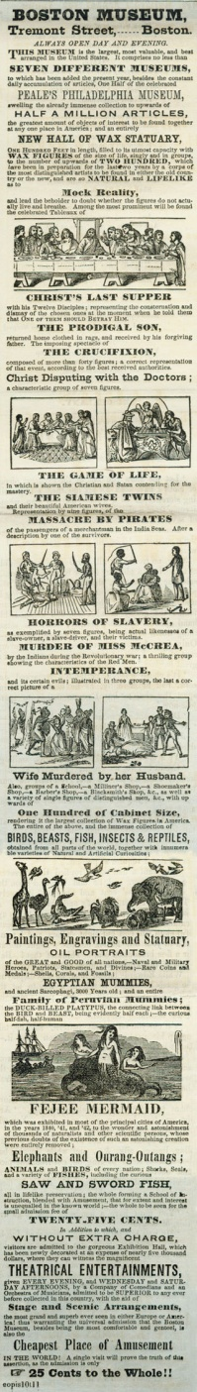

Fig 19 Installations of ethnographic items at the Peabody Museum of Archaeology and Ethnology, Harvard University, c 1900.

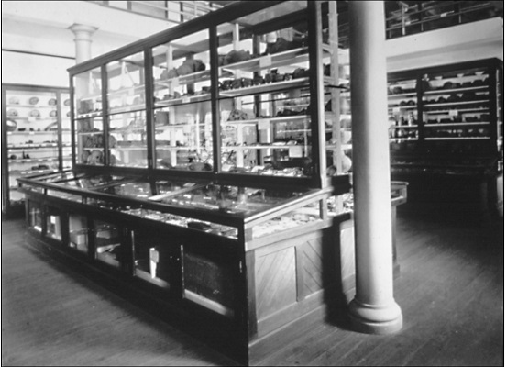

Fig 20 Pages with botanical specimen and field notes on Indigenous language and knowledge recorded by Frederick Waugh, National Museum of Canada ethnographer, during his visit to the Six Nations of the Grand River, Ontario in 1911. CMH Archives E200-20.1.050 and E200-20.1.051. Photo: Canadian Museum of History

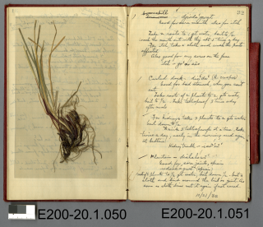

Fig 21 Museum aan de Stroom, Antwerp. Photo, Zinneke, Wikepedia Commons

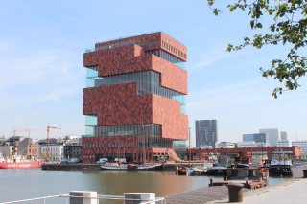

Fig 22 Installation from “Displays of Power” exhibition, Museum aan de Stroom, Antwerp, 2015. Photo: Author

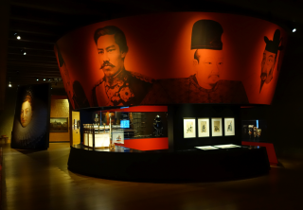

Fig 23 Musée des Confluences, Lyon . Photo: Author

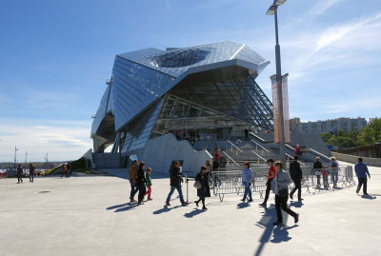

Fig 24 Musée des Confluences, ‘Origins’ installation of paleontology and Australian aboriginal art, Photo: Author

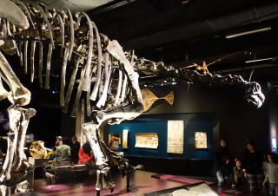

Fig 25 ‘Everything Else’, *Grover and the Everything in the Whole Wide World Museum*

