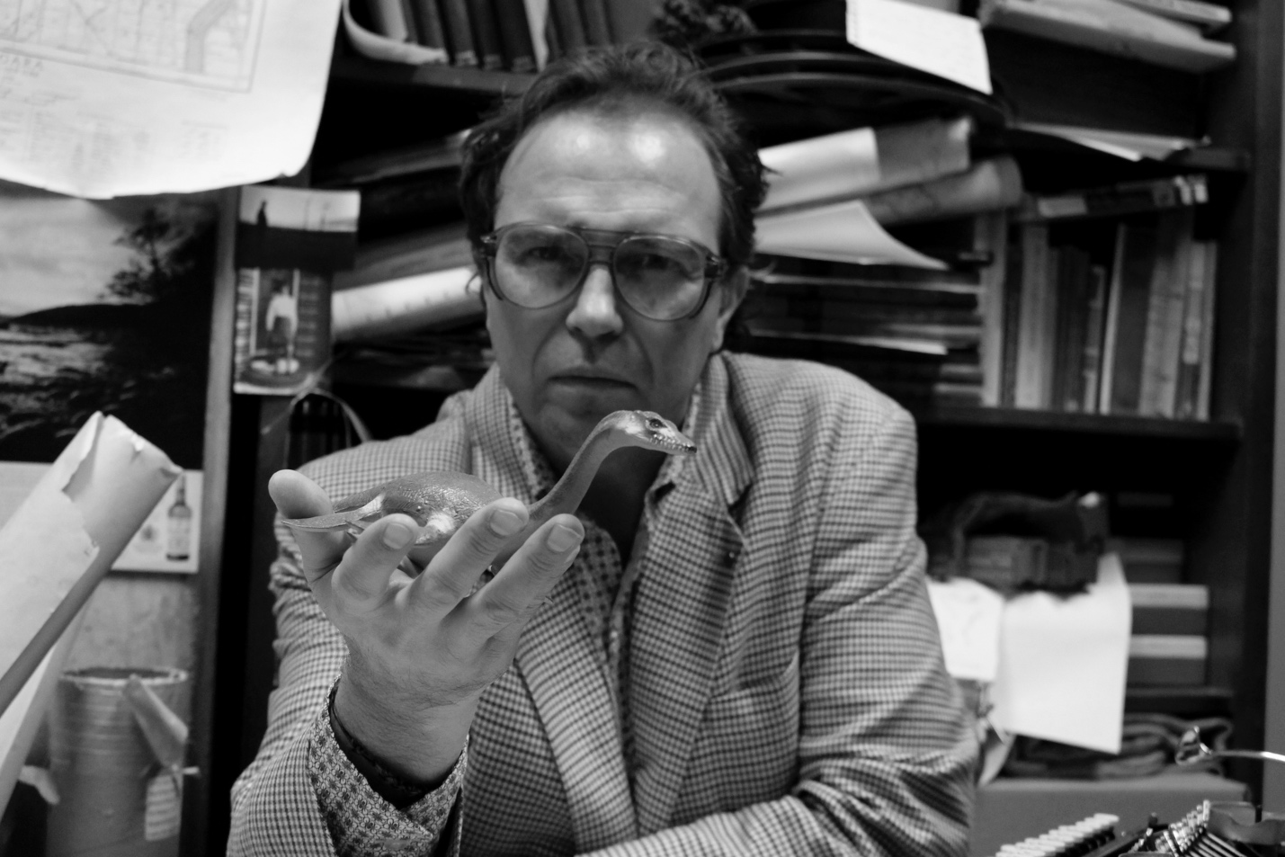

Figure 1. Arthur Nestor in his office, circa 1975, photo credit Mackenzie Sinclair

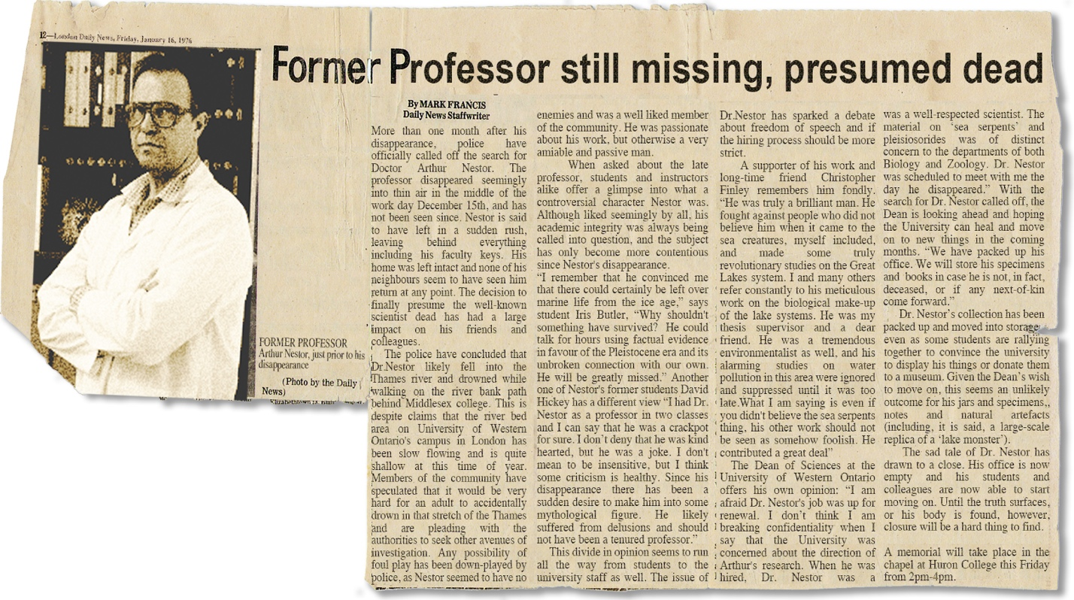

Figure 2. London Daily News article documenting Arthur Nestor’s disappearance, January 16, 1976

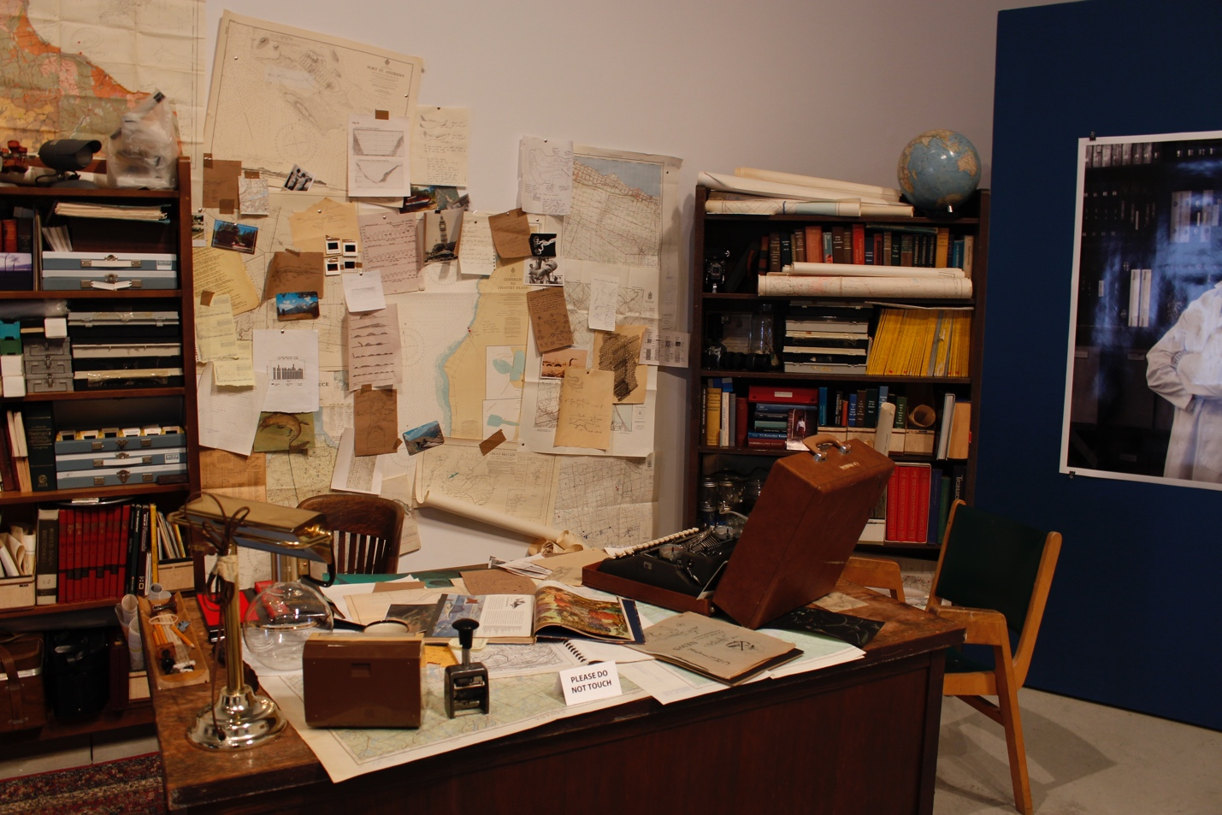

Figure 3. Beneath the Surface: Archives of Arthur Nestor installation shot, detail, February 2014, photo credit Mackenzie Sinclair

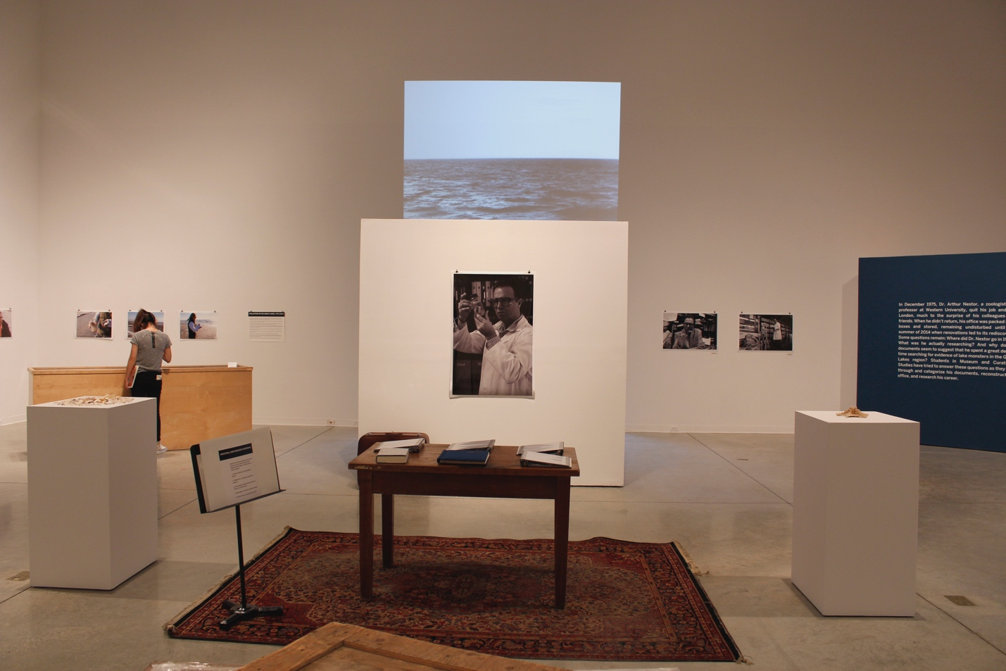

Figure 4. Beneath the Surface: Archives of Arthur Nestor installation shot, detail, February 2014, photo credit Mackenzie Sinclair

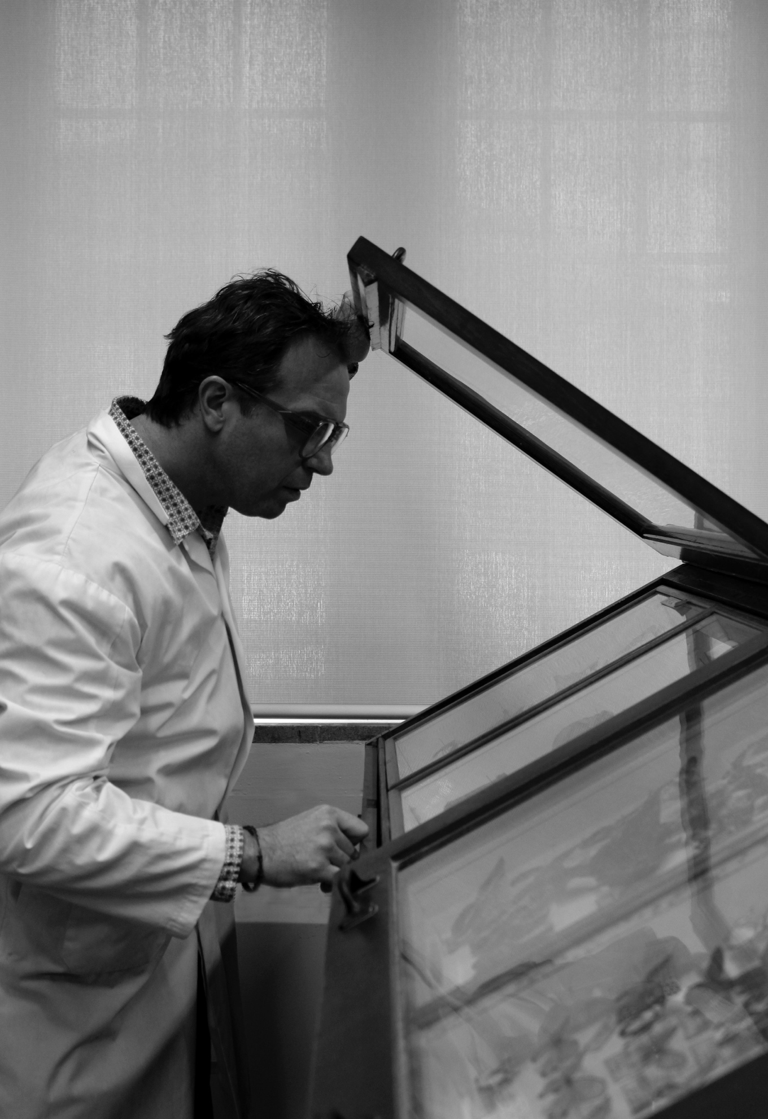

Figure 5. Arthur Nestor examining the butterfly collection, photo credit Mackenzie Sinclair

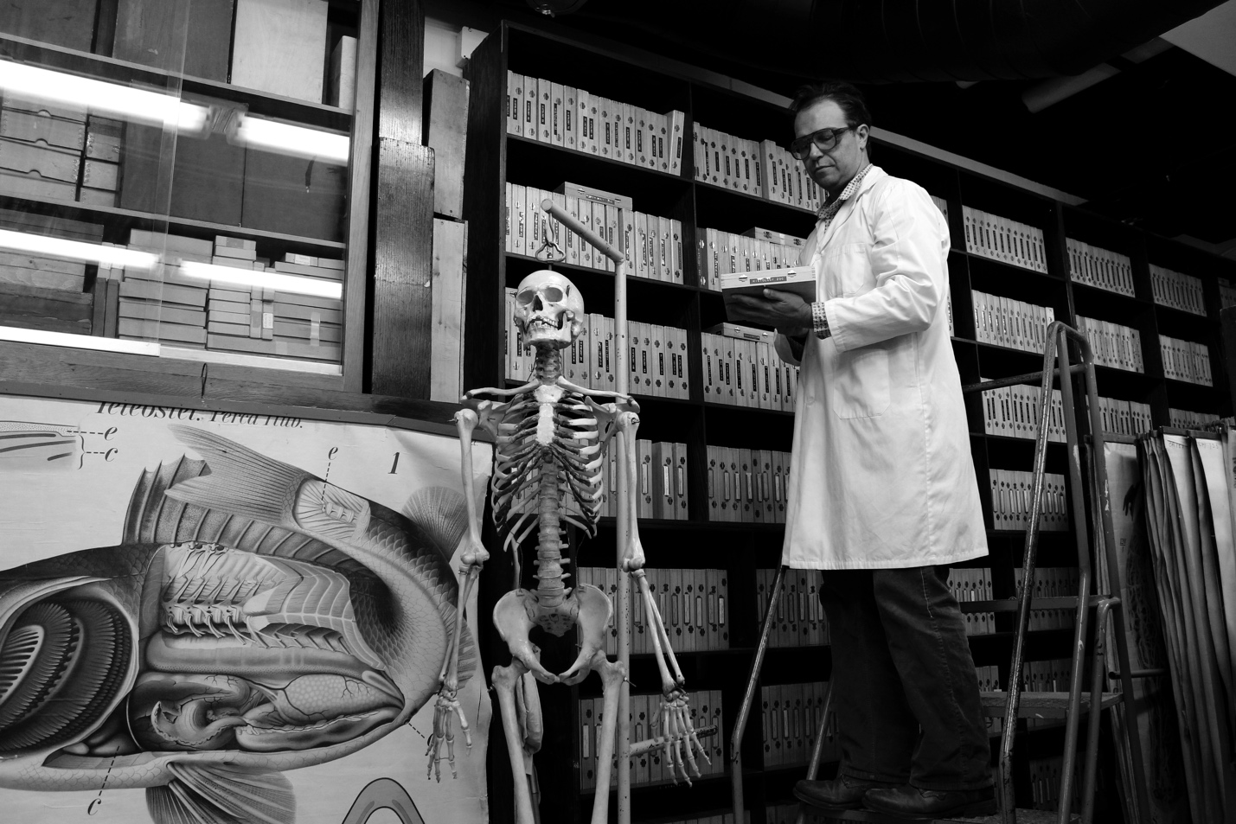

Figure 6. Arthur Nestor in the Zoology Collection, photo credit Mackenzie Sinclair