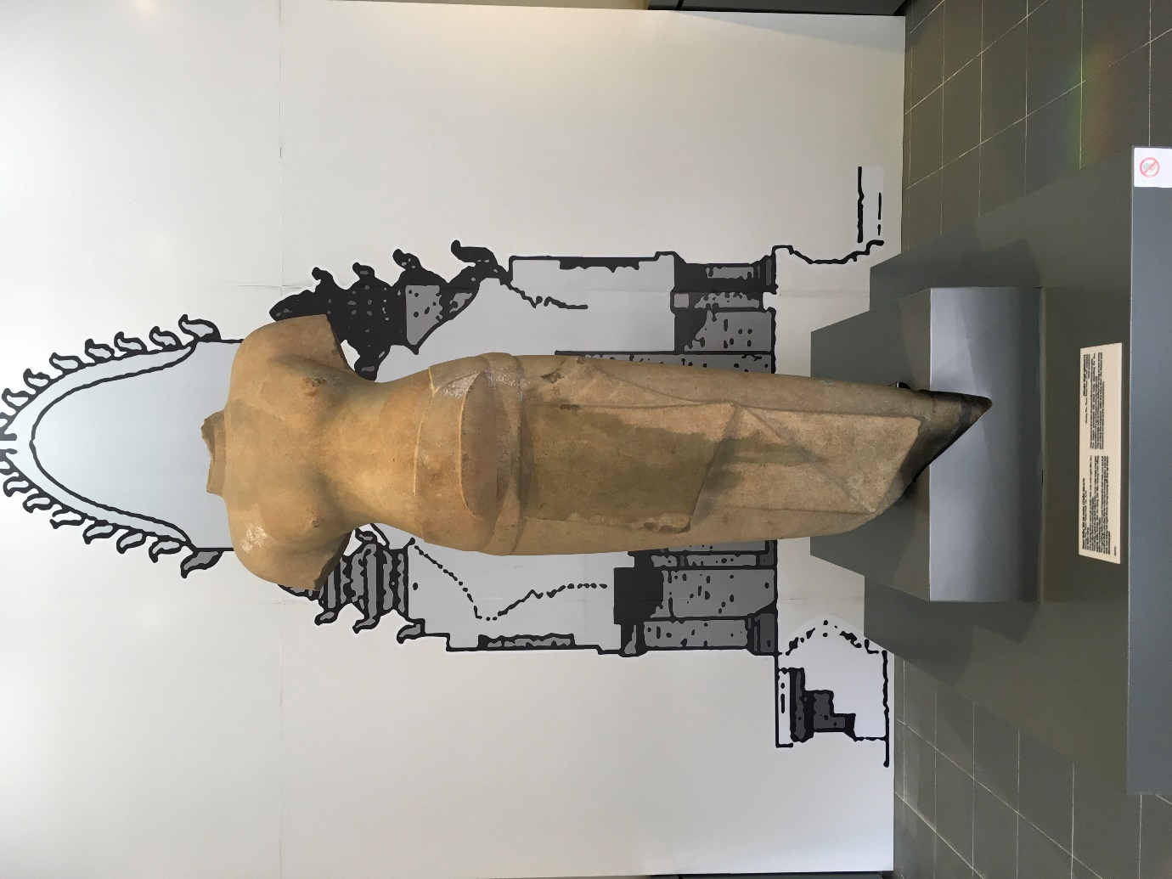

Figure 1: Male deity sculpture in the Cham exhibition hall, Royal Antiquities Museum, Hue

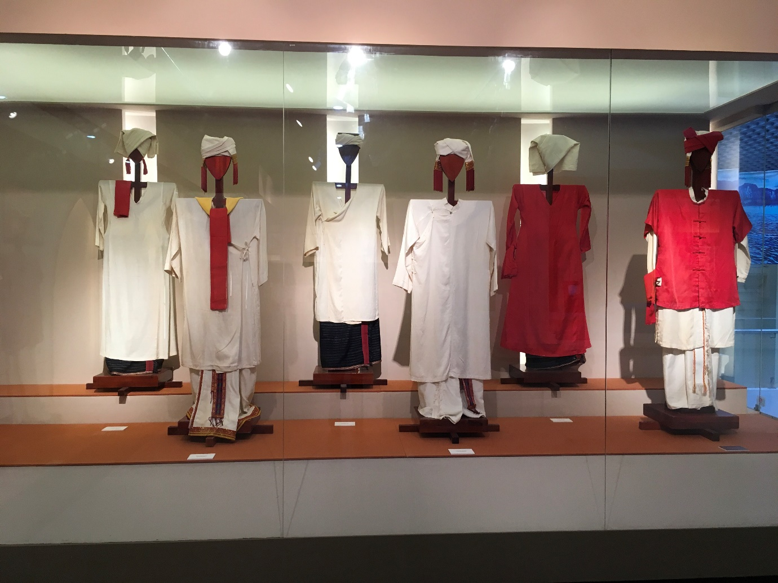

Figure 2: The Cham folklore section at the Cham sculpture museum in Da Nang

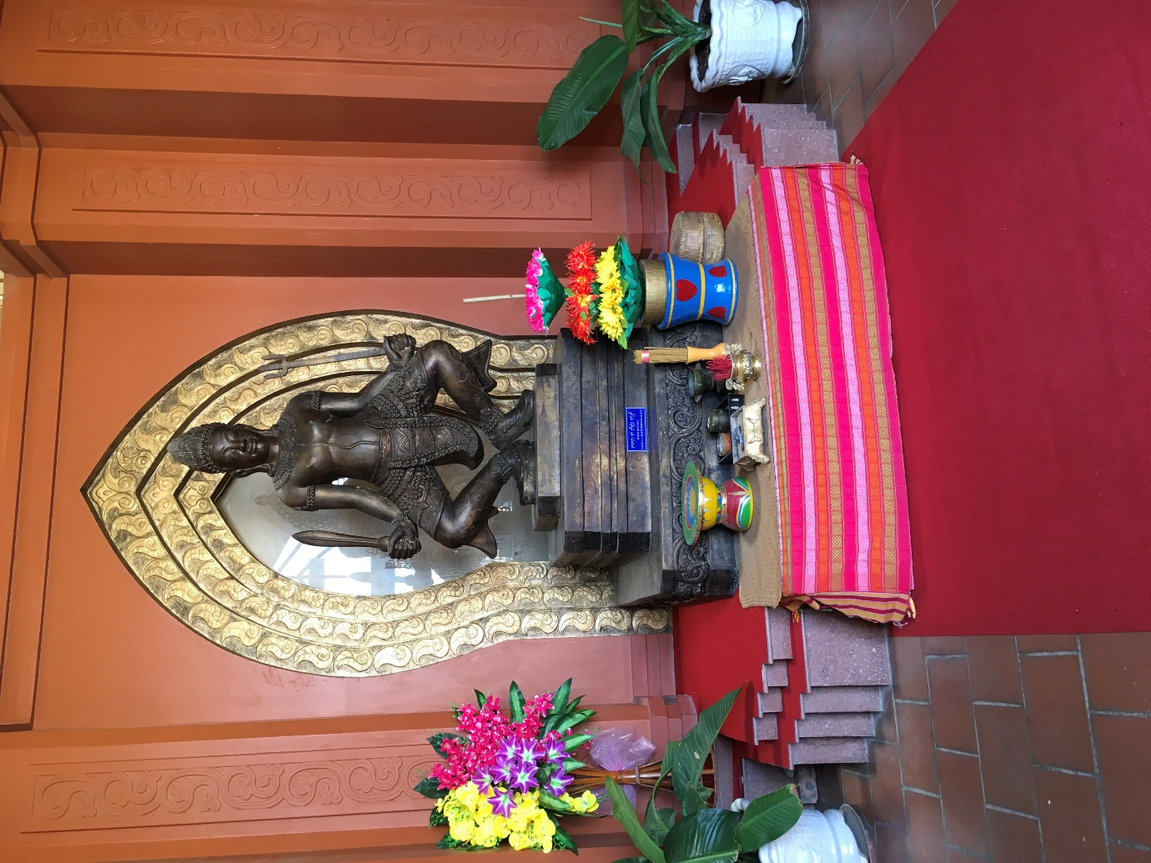

Figure 3: Siva statue at the entrance of the Cham Cultural Centre in Binh Thuan