Figure 1 & 2. Two views of the Canadian Journeys Gallery (author photographs)
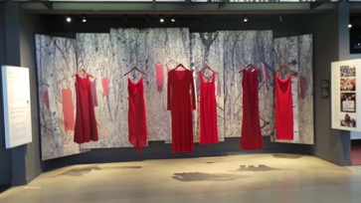
Figure 3. A close up of the exhibit Aboriginal Women and the Right to Safety and Justice (author photograph).

Figure 4. Aboriginal Women and the Right to Safety and Justice exhibit in relation to the entire Canadian Journeys Gallery (author photograph)

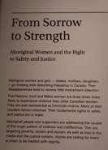

Figure 5. Opening text panel of the exhibit Aboriginal Women and the Right to Safety and Justice (author photograph).
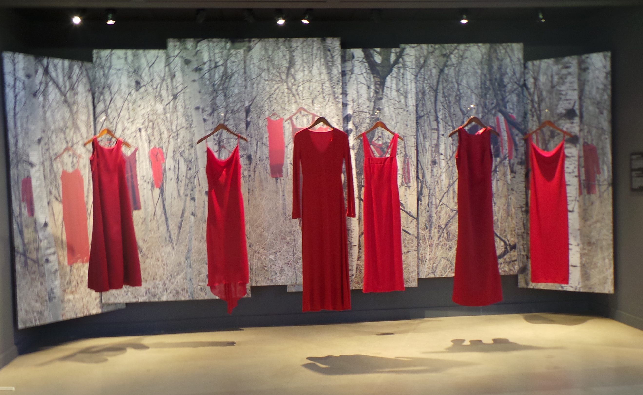

Figure 6. The focal areal of Aboriginal Women and the Right to Safety and Justice (author photograph).

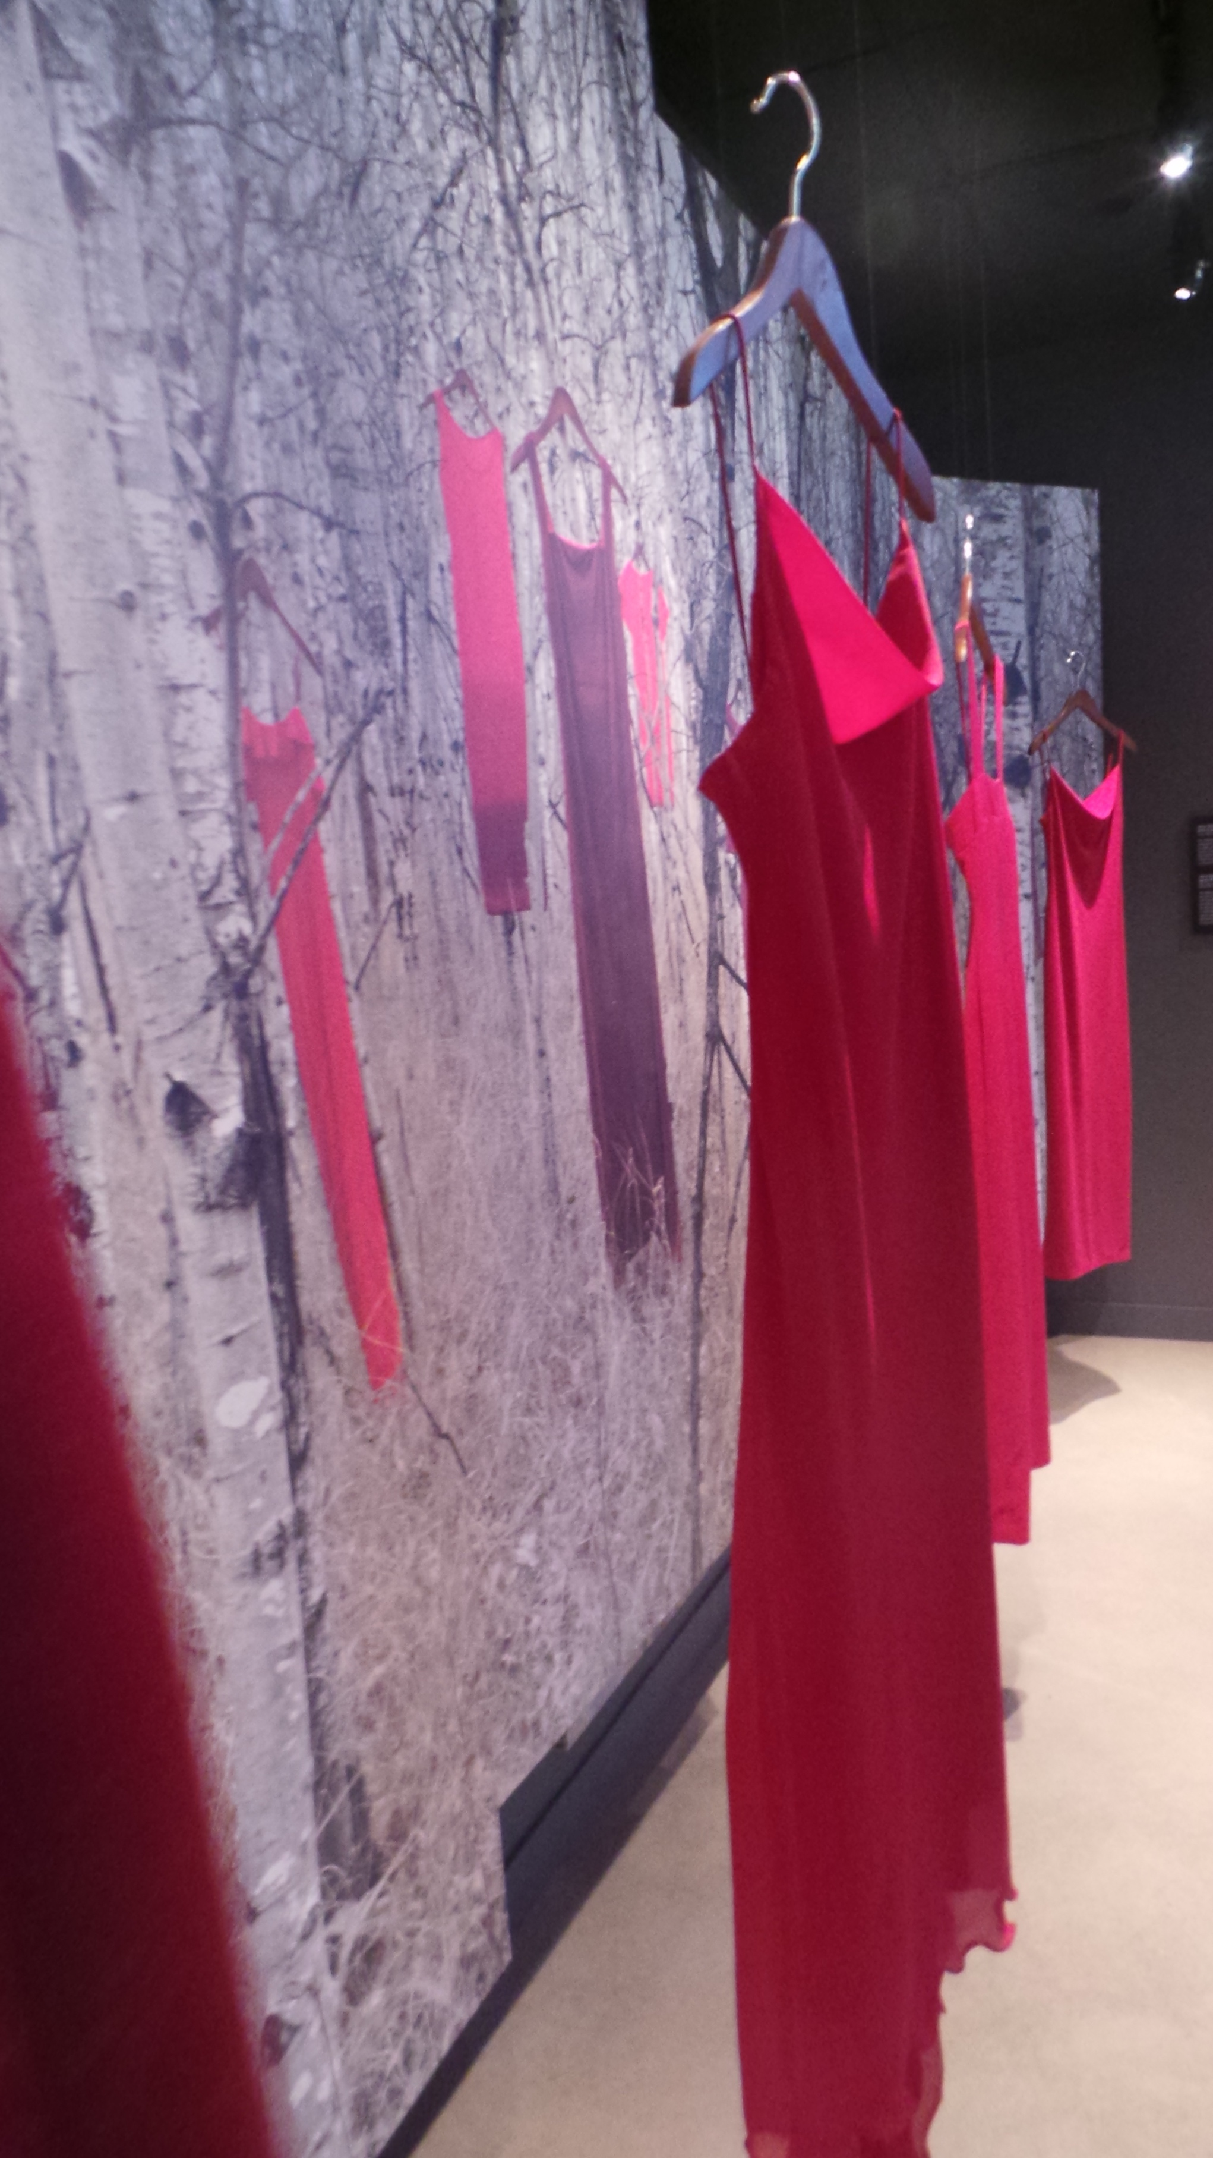
Figure 7. A close up of the focal area of the exhibit. (author photograph).

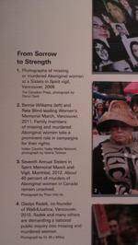
Figure 8. The right side-panel featuring four photographs and corresponding text (author photograph).

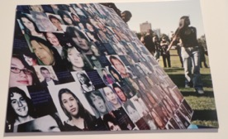
Figure 9. Photograph 1 from the right side-panel (author photograph).

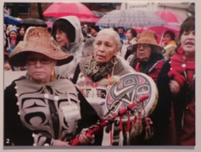
Figure 10. The second photograph on right side-panel (author photograph).

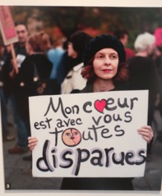
Figure 11. The third photograph on the right side-panel (author photograph).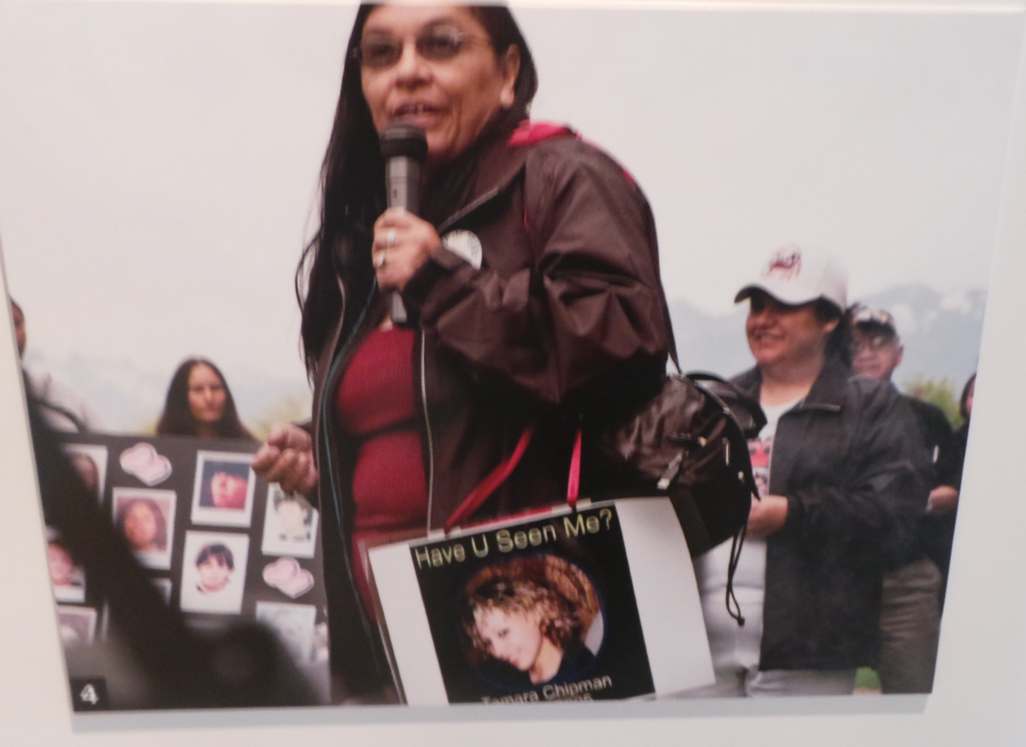
Figure 12. The fourth photograph on the right side-panel (author photograph).

