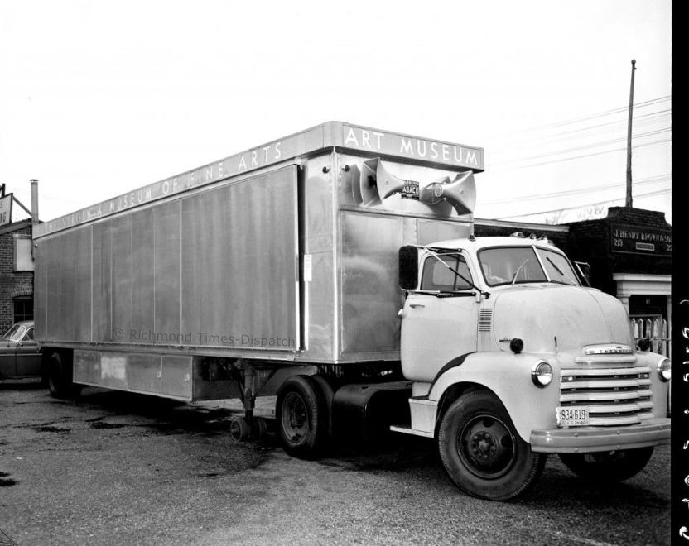

Figure 1. “Artmobile I,” 1954. VMFA Photo Archives. © Richmond Times-Dispatch.

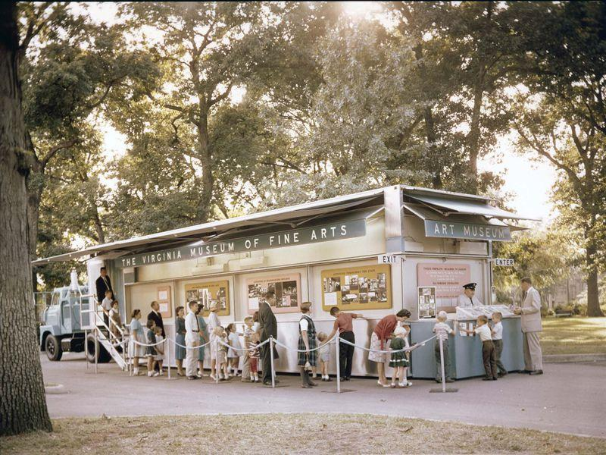

Figure 2. Twelve Portraits: Delacroix to Gaugin exhibition. 1962. VMFA Photo Archives. © Virginia Museum of Fine Arts.

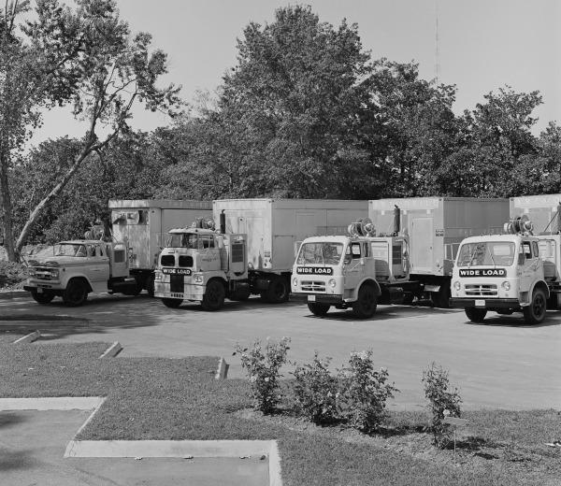

Figure 3. Four Active Artmobiles Parked in the Virginia Museum of Fine Arts Parking Lot, 1967. VMFA Photo Archives. © Virginia Museum of Fine Arts.

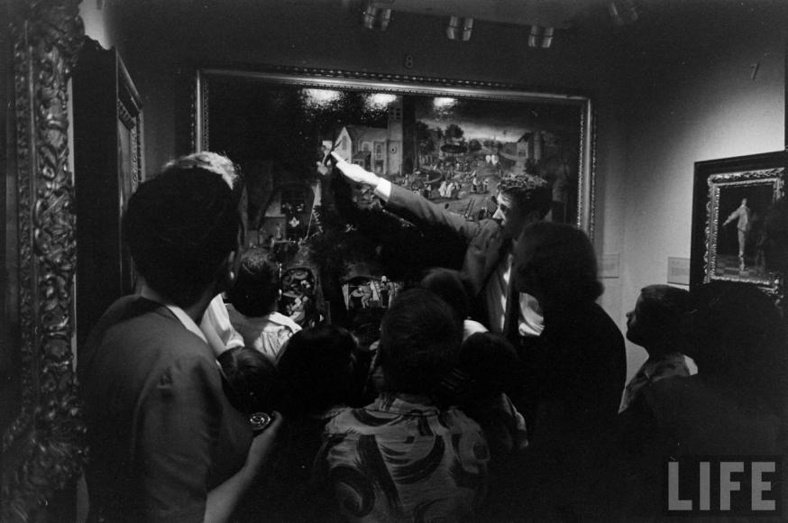

Figure 4. George Skadding, Driver-Curator William Gaines at Little Dutch Masters, “Artmobile – Wise, Virginia” series, Life Magazine, 1954.

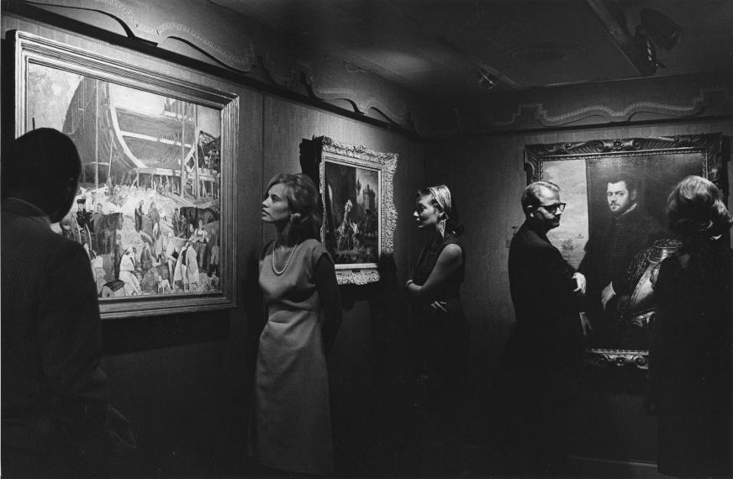

Figure 5. The Williams Collection exhibition. 1965. VMFA Photo Archives. © Virginia Museum of Fine Arts.

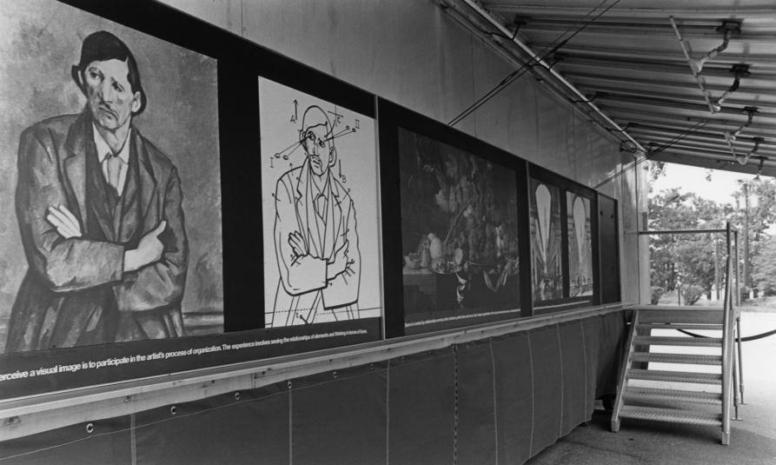

Figure 6. Encounter I: Space exhibition. 1971. Exterior Panels. VMFA Photo Archives. © Virginia Museum of Fine Arts.

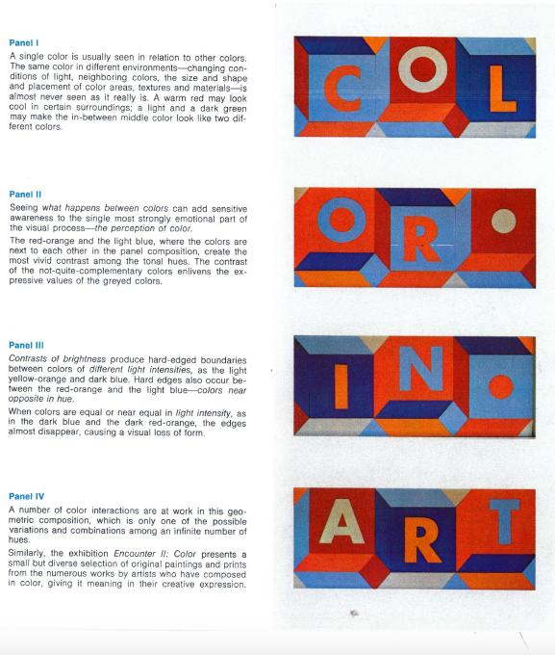

Figure 7. A page from the Encounter II: Color exhibition pamphlet, in which color theories were explained through comparison and contrast. 1972. VMFA Photo Archives.
©Virginia Museum of Fine Arts.

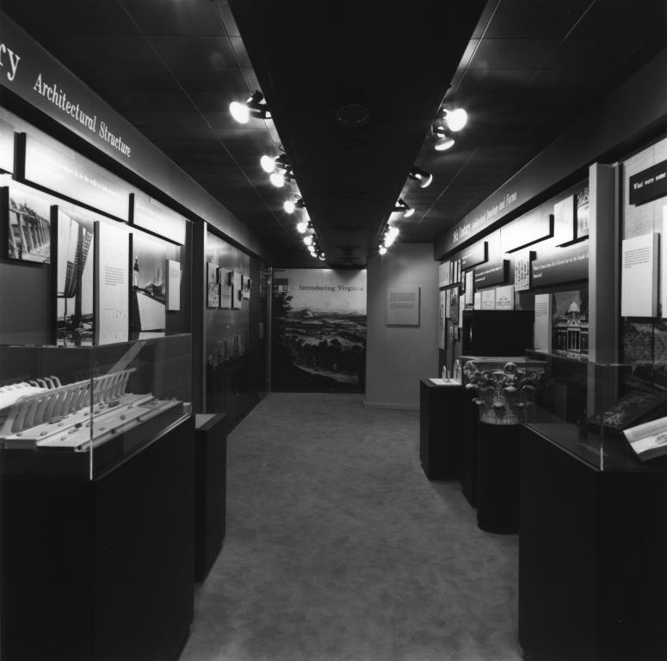

Figure 8. Introducing Virginia Architecture. 1992. VMFA Photo Archives. ©Virginia Museum of Fine Arts.

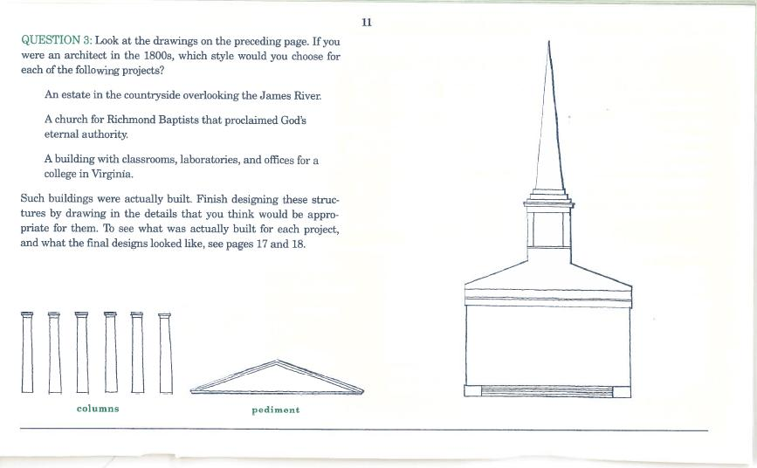

Figure 9. A page from the Introducing Virginia Architecture booklet. 1992. VMFA Photo Archives. ©Virginia Museum of Fine Arts.

