Images Museums & Society, June 2018

Article: Images Adaptive Institutional Change: managing Digital Works at the Museum of Modern Art

Authors: Vivian van Saaze, Glenn Wharton, Leah Reisman

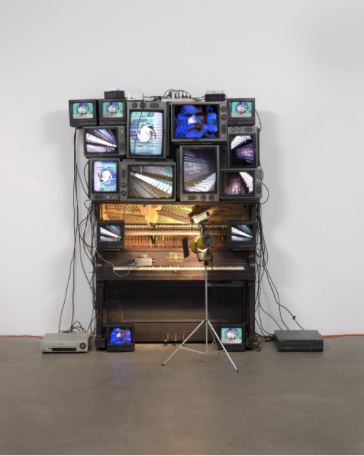

NB I haven’t managed to secure permission yet. Please do not include in the article!!!! Figure 1. Nam June Paik. *Untitled*. 1993. Player piano, 15 televisions, two cameras, two laser disc players, one electric light and light bulb, and wires, overall approx. 8′ 4″ x 8′ 9″ x 48″ (254 x 266.7 x 121.9 cm), including laser disc player and lamp. Bernhill Fund, Gerald S. Elliot Fund, gift of Margot Paul Ernst, and purchase. © 2013 Estate of Nam June Paik.

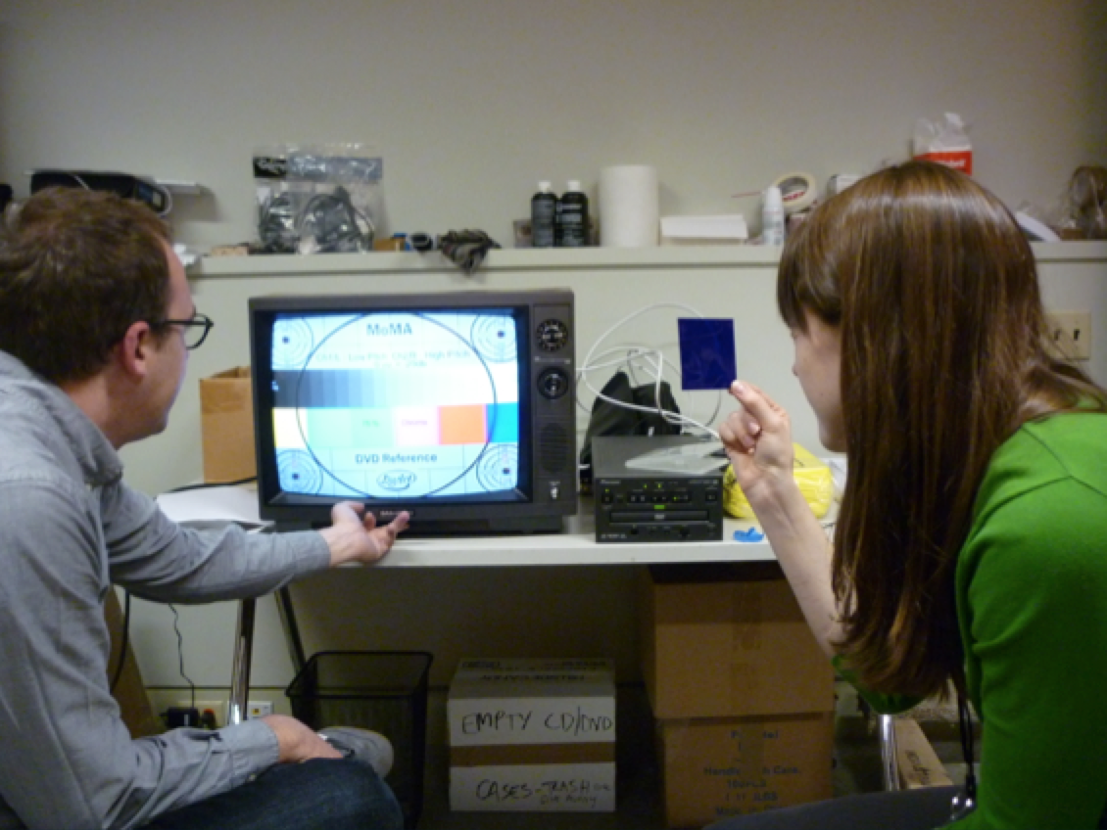

Figure 2. [becomes Figure 1, if permission to use image of Paik is not granted in time for the deadline] Assistant Media Conservator Peter Oleksik and Conservation Fellow Emily Hamilton assessing the condition and calibrating a cathode-ray tube monitor. Photo: Glenn Wharton.

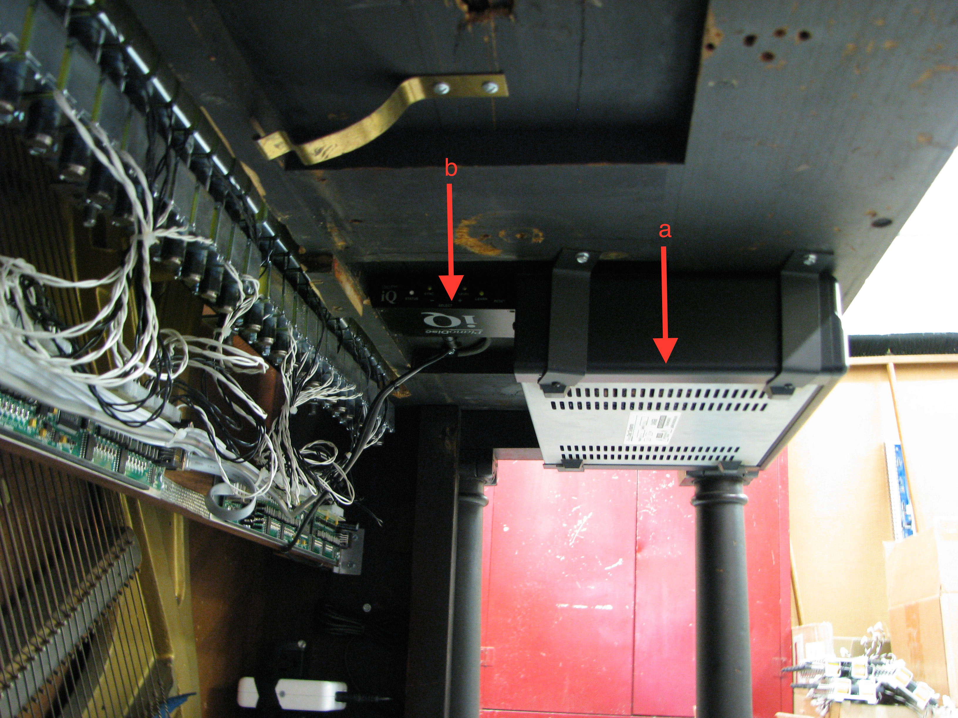

Figure 3. [becomes Figure 2, if permission to use image of Paik is not granted in time for the deadline] View of the underside of the piano keyboard. The old player piano unit (“a”) is on the right and remains visible to the viewer. The new unit (“b”) is on the left and is only visible from the underside of the keyboard. Photo: Glenn Wharton.

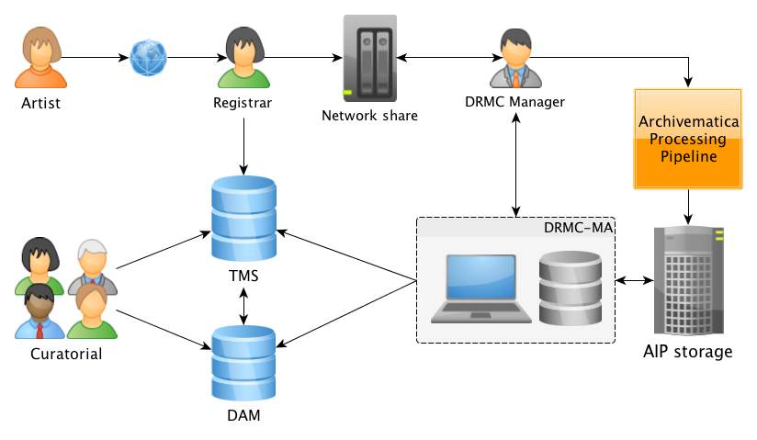

Figure 4. [becomes Figure 3, if permission to use image of Paik is not granted in time for the deadline] Diagram depicting the socio-material processing of digital art through MoMA’s DRMC, TMS, and DAM (2013). Credit: Ben Fino-Radin, DRMC Manager.