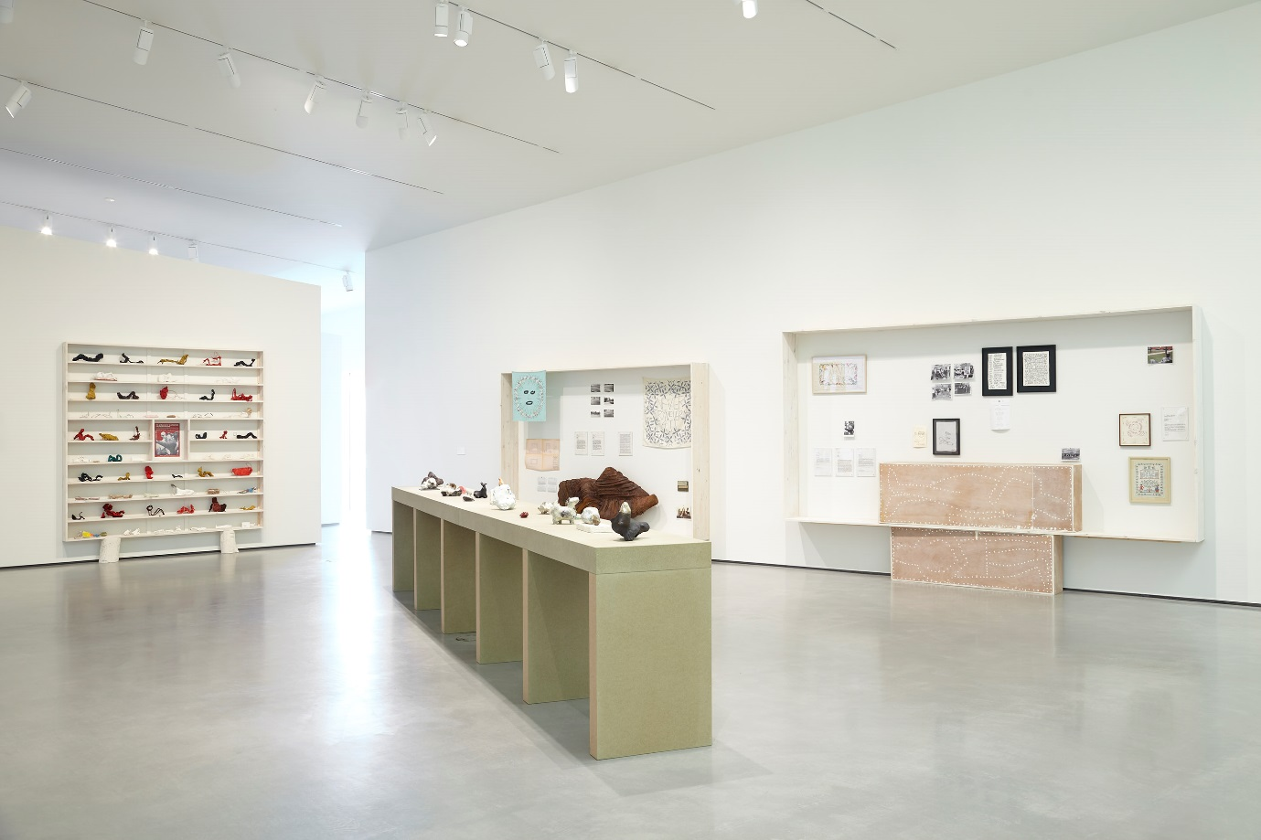

Fig. 1, Installation view of *Des Hughes:* *Stretch Out and Wait*, including school children’s work seen to the left of the image. Photo: Stuart Whipps. Image courtesy The Hepworth Wakefield and Des Hughes.

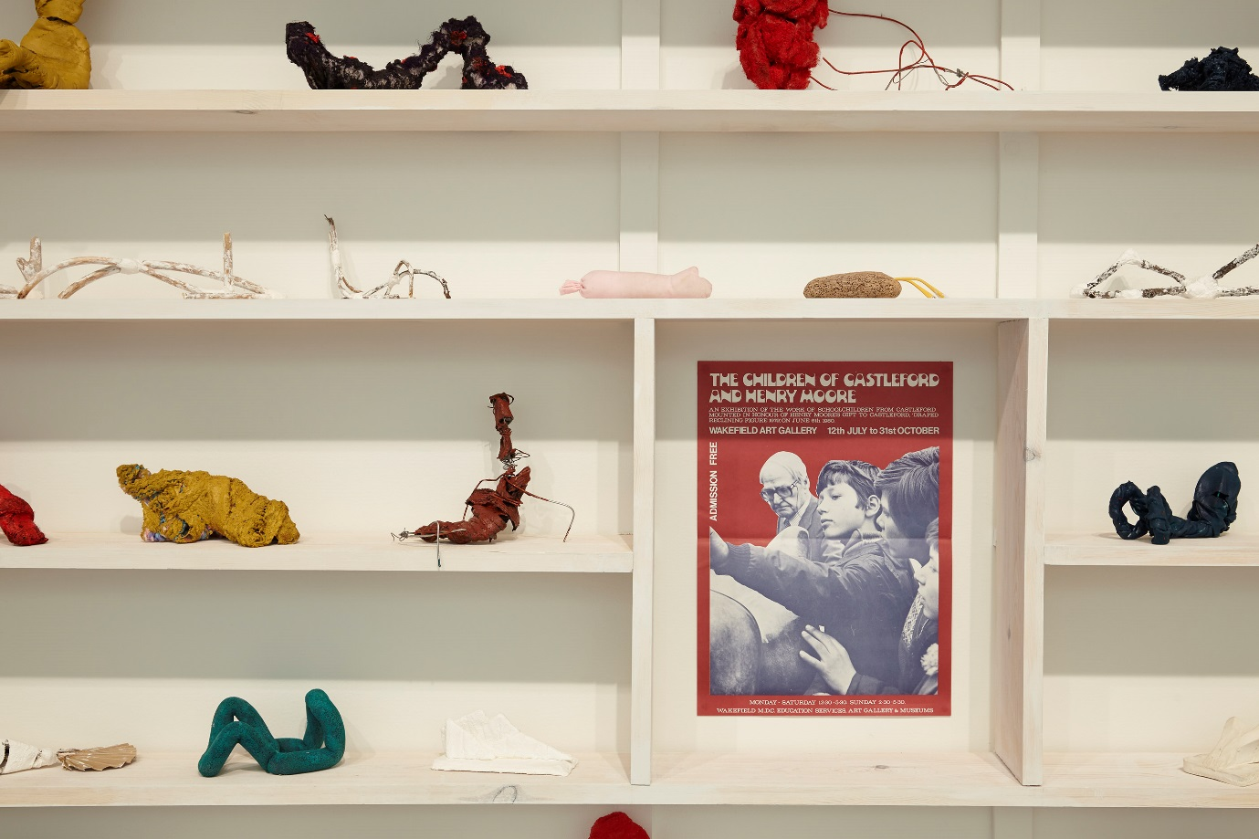

Fig. 2, Detail of school children’s work included in Des Hughes’ exhibition, *Stretch Out and Wait.* Photo: Stuart Whipps. Image courtesy The Hepworth Wakefield and Des Hughes.

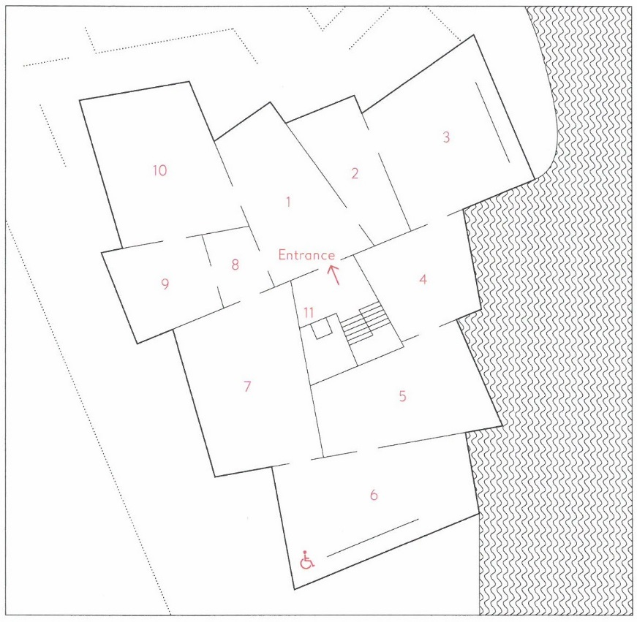

Fig. 3. Map of galleries which form a closed circuit. ‘What’s On: Summer 2014’, The Hepworth Wakefield.

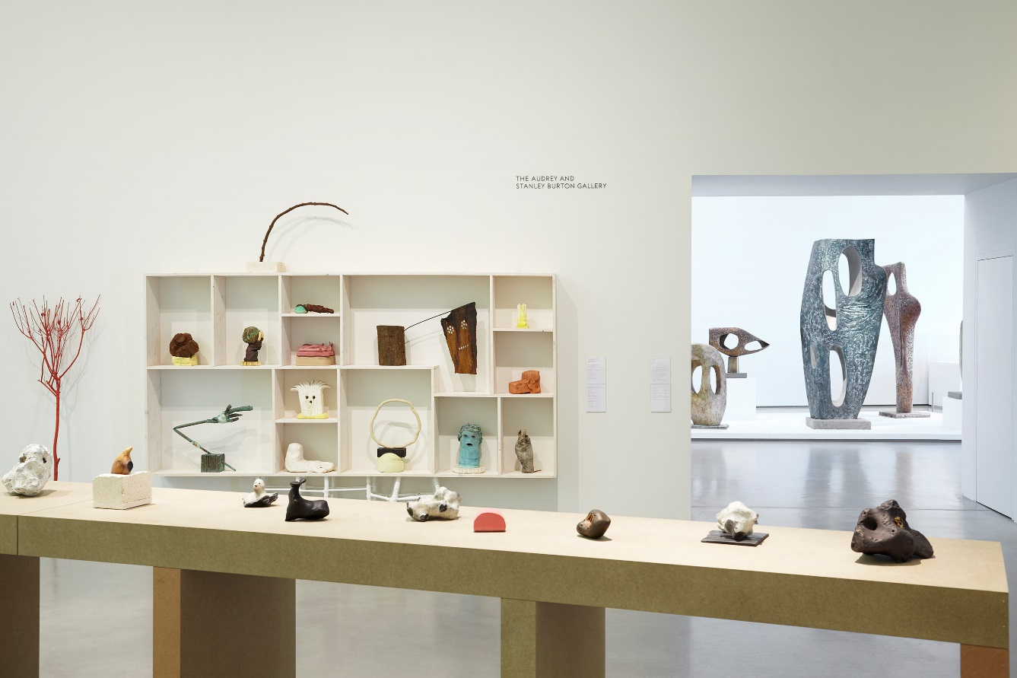

Fig. 4, Installation view of Des Hughes: *Stretch Out and Wait*, looking through to Barbara Hepworth’s work in Gallery 5*.* Photo: Stuart Whipps. Image courtesy The Hepworth Wakefield and Des Hughes.