Figures
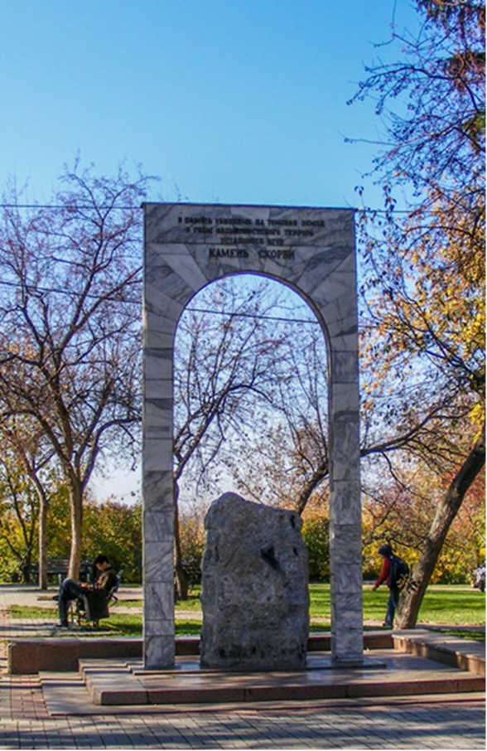
Figure 1: The privatization of memory. Stripped of any Motherland-centric symbolic framing, the Stone of Grief is more akin to private gravestones in ordinary cemeteries. (Author’s photo)
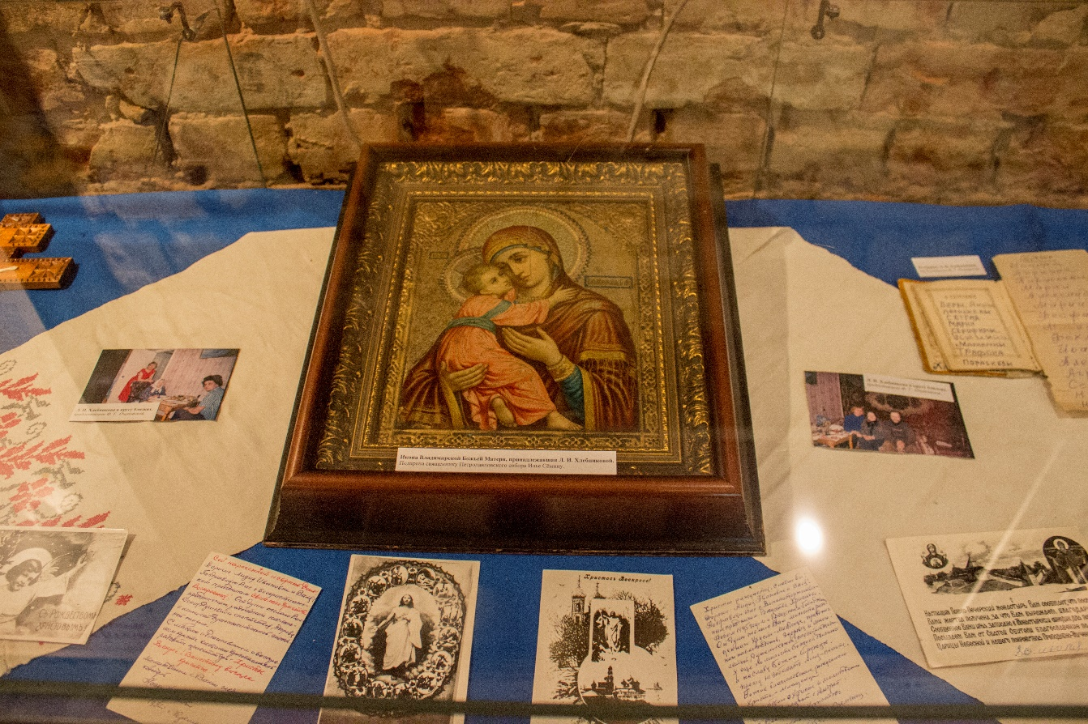
Figure 2. The Christianization of memory. Note how the letters and photographs depicting the prisoners’ lives are organized around the Christian Orthodox icon. (Author’s photo)

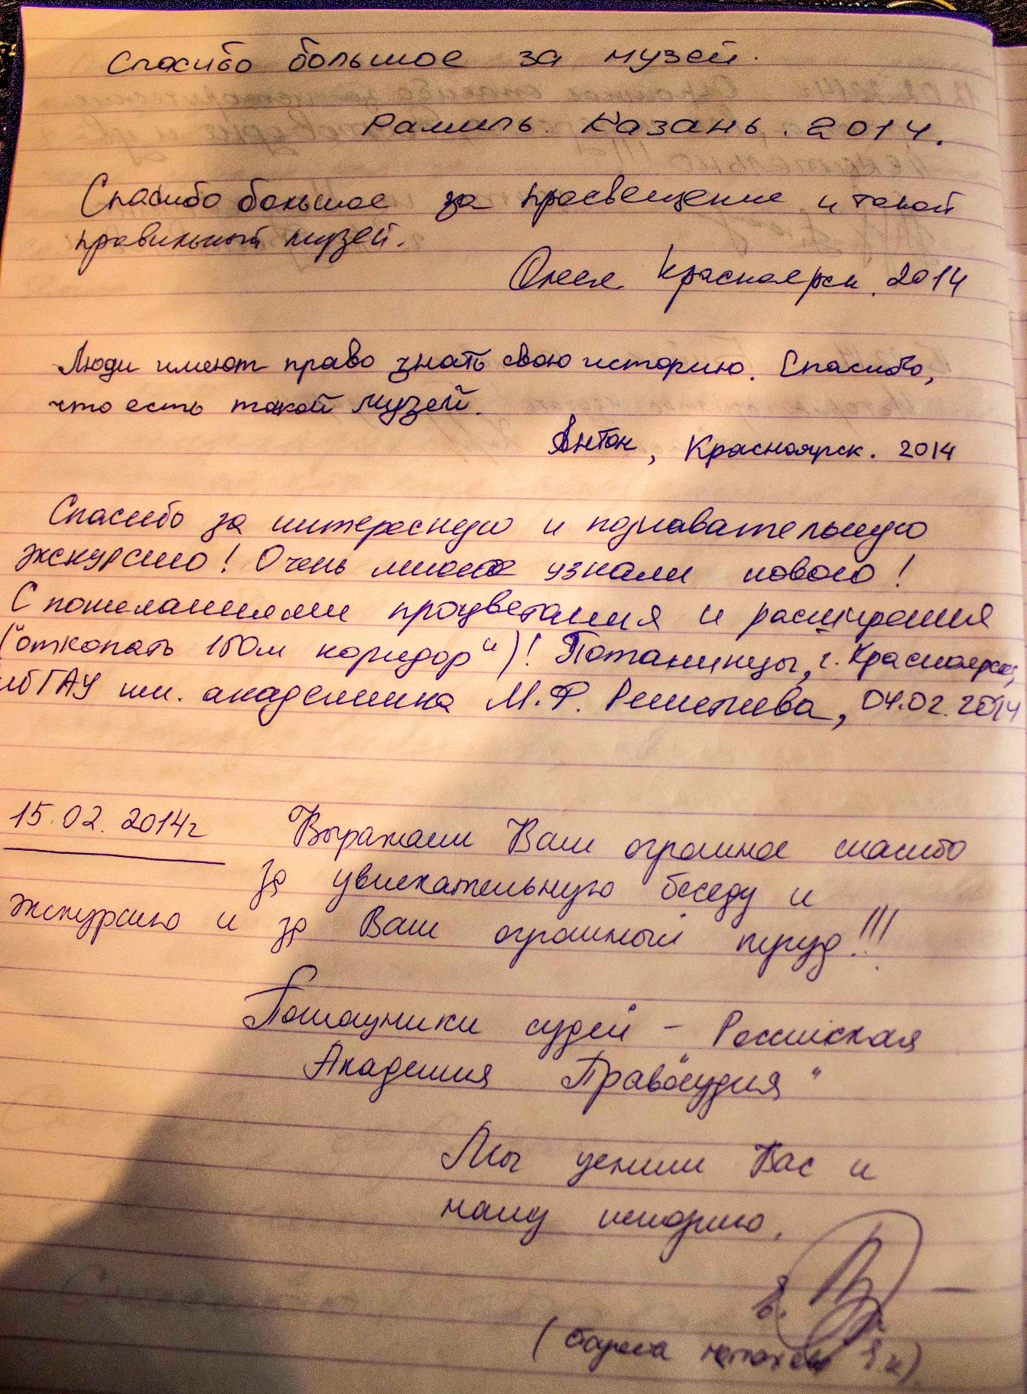
Figure 3. ‘Thank you for an interesting and informative excursion!’ For many visitors, the Stalinist atrocities are interesting rather than unforgettable. (Author’s photo)

