**Journal of Interdisciplinary Science Topics**

**If University of Leicester’s Charles Wilson building were a transformer, how much fuel would it need to stand up?**

Derryn Grant

*The Centre for Interdisciplinary Science, University of Leicester*

15/03/2018

**Abstract**

In 1966, construction of the now infamous Charles Wilson building was completed. Unknown to it’s designer, Sir Denys Lasdun, it would later be affectionately known as the Optimus Prime building due to its uncanny resemblance to the transformer. A transformer being from the popular children’s franchise in which cars have the ability to transform into sentient, humanoid robots. This paper aims to quantify the amount of fuel that would be needed for the building to stand, if it were a transformer. The energy needed for the Charles Wilson building to stand up, like a transformer, is approximately 281.02 MJ, requiring 7.34 L of kerosene and making the motion less fuel efficient than a Boeing 747.

**Introduction**

In the 1960s, Sir Denys Lasdun designed Charles Wilson building (CW) (Figure 1). The building is one of three which decorate the skyline of University of Leicester. Nowadays CW is known for its likeness to notable transformer Optimus Prime and so this paper seeks to quantify the amount of fuel that would be needed to allow the building, if it were a transformer, to stand up like that of a human. This paper assumes that the building only makes up the head to waist of the transformer and so the legs have to be approximated.

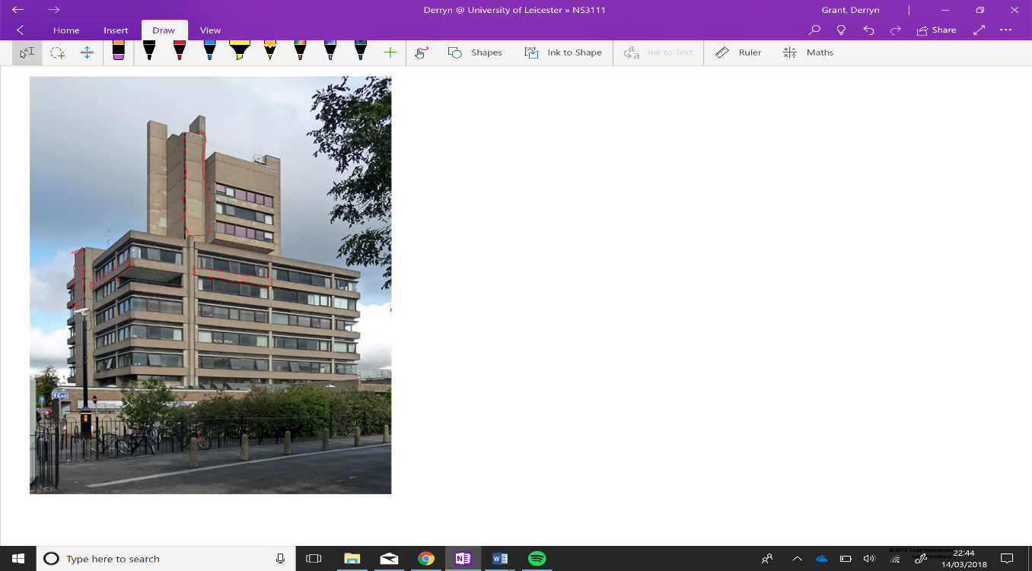

Figure 1: Photo of Charles Wilson Building. In red are examples of the concrete blocks counted to carry out calculations. [1]

**How high would the building need to rise to be considered standing?**

It is assumed that the building has approximately the same dimensions as a transformer, so the ‘legs’ would be 45% of the height of the building. CW is 52 m in height, hence this would equal the rest of the body and the ‘legs’ of the building would lift it by 28 m [2]. Resulting in the total standing height of 80 m.

**Weight of the building**

The specific dimensions of the building have been assumed in order to make these calculations. The weight of the building only takes into account the concrete of which the building is made and so the building is assumed to be mostly empty inside.

CW is made of precast concrete units, 15.24 metres long and weighing 9.5 tonnes each [2]. These units are shown in red in Figure 1. Thus, to calculate the approximate weight of the building, these units are counted from photos. The total weight of the building is calculated to be approximately 665 tonnes, or 665,000 kg.

If this were to include the ‘legs’ of the building, the assumption is made, again, that the weight of the building is 65% of the total weight of the transformer. This assumes that the ‘legs’ would be made of the same materials. If this were the case, the total weight would be 1,023,076 kg.

**How much energy would this require?**

The force required for the building to rise would have to be greater than the force acting downward on it, gravity. This is found as follows:

$$F=MA \\ =1,023,076 kg ×9.81 {ms}^{-2}$$

$$=10,036,385 N$$

Where, F is force needed to lift the building, M is the mass of the building and A is the acceleration or in this case the gravitational constant due to the force being exerted upward.

To find the energy required to exert such a force the work done must be calculated as follows:

$$W=Fd=10,036,385 N×28 m=281,018,769 J=281.02 MJ$$

Where, W is the work done, F is force required to lift the transformer up and d is the distance the building travels up.

The energy density of gasoline is approximately 33.9 MJ/L and so this amount of energy would require at least 8.29 L of gasoline [3]. Whereas kerosene has the energy density of 38.3 MJ/L requiring at least 7.34 L of kerosene [3].

To put this into perspective, planes like a Boeing 747 can use around 4 L of fuel every second during a flight [4]. The Boeing can burn through 12 L/km during a flight whilst this motion of the building standing takes 262 L/km [4]. Thus, this motion is much less energy efficient.

**Conclusion**

The energy needed for the Charles Wilson building to stand up, like a transformer, is approximately 281.02 MJ. This amount can be carried out using 8.29 L of gasoline or 7.34 L of kerosene. However, the use of kerosene would use 262 L/km, much less efficient than the 12 L/km Boeing claims their 747 model burns through on average during flight.

**References**

1. Richards, S. (2018). *Charles Wilson Building, University... (C) Stephen Richards.* Geograph.org.uk. Available at: http://www.geograph.org.uk/photo/3120270 [Accessed 14 Mar. 2018].
2. Skyscrapernews.com. (2018). *The Charles Wilson Building, Leicester - Building #6113*. Available at: http://www.skyscrapernews.com/buildings.php?id=6113 [Accessed 14 Mar. 2018].
3. Neutrium.net. (2018). *Specific Energy and Energy Density of Fuels – Neutrium.* Available at: https://neutrium.net/properties/specific-energy-and-energy-density-of-fuels/ [Accessed 14 Mar. 2018].
4. Garden, H. (2018). *How much fuel does an international plane use for a trip?.* HowStuffWorks. Available at: https://science.howstuffworks.com/transport/flight/modern/question192.htm [Accessed 14 Mar. 2018].